|  |  |  |  |  |
| --- | --- | --- | --- | --- |
|  | | | | |
| **JOB TITLE:** | Senior Estimator | | | |
|  |  |  |  |  |
| Location: |  |  | Date: |  |
|  |  |  |  |  |
| Reports to: |  | | | |
|  |  |  |  |  |
| Purpose: | To assess and analyse project requirements to provide accurate and competitive cost estimates. | | | |
|  |  |  |  |  |
| **ROLE SUMMARY:** | | | | |
| Having started providing electrotechnology services in 1936, McKay is a historic New Zealand electrical company with a depth of experience in providing end to end electrical solutions for a wide range of industries and sectors. McKay is the parent brand and has acquired and started a range of companies under the McKay Group name in order to serve all electrical needs.  As a Senior Estimator at McKay Electrical Ltd., you will play a crucial role in our organisation by assessing and analysing project requirements with a view to providing accurate and competitive cost estimates. You will be heavily involved in the pre-construction phase, collaborating with project managers, engineers, and clients to ensure the successful execution of electrical projects. Your expertise will contribute to the overall profitability and success of the organisation. | | | | |

|  |
| --- |
| RESPONSIBILITIES: |

1. **Project Assessment:**
   * Review and analyse project specifications, drawings, and other documents to understand the scope and requirements.
   * Conduct site visits and collaborate with project stakeholders to gather relevant information for accurate estimations.
2. **Cost Estimation:**
   * Prepare detailed and accurate cost estimates for electrical projects, including materials, labour, equipment, and overhead costs.
   * Utilise industry-specific software and tools to enhance the accuracy and efficiency of the estimation process.
   * Stay updated on market trends, pricing, and industry developments to ensure competitiveness.
3. **Bid Preparation:**
   * Develop comprehensive bid proposals, ensuring compliance with project specifications and client requirements.
   * Collaborate with the business development team to prepare persuasive proposals that highlight the company's strengths and capabilities.
4. **Risk Assessment:**
   * Identify potential risks and uncertainties associated with project execution and incorporate contingency plans into cost estimates.
   * Work closely with project managers and other stakeholders to assess and mitigate risks during the pre-construction phase.
5. **Collaboration:**
   * Liaise with internal teams, subcontractors, suppliers, and clients to gather information and ensure accurate estimation.
   * Foster positive relationships with key stakeholders and participate in pre-bid meetings and negotiations.
6. **Value Engineering:**
   * Evaluate alternative materials and methods to optimise project costs without compromising quality or safety.
   * Provide value engineering suggestions to enhance the overall value proposition for clients.
7. **Documentation and Reporting:**
   * Maintain detailed records of project estimates, assumptions, and methodologies.
   * Generate regular reports for management, highlighting key cost drivers, potential risks, and opportunities.
8. **Continuous Improvement:**
   * Stay abreast of industry best practices and advancements in estimating techniques.
   * Provide feedback to enhance internal processes and contribute to the continuous improvement of the estimating department.

|  |
| --- |
| QUALIFICATIONS & KNOWLEDGE: |

* Bachelor's degree in electrical engineering, construction management, or a related field (or equivalent work experience).
* Proven experience as an electrical estimator or in a similar role within the electrical industry.

|  |
| --- |
| ROLE PROFILE: |

As a Senior Estimator at McKay Electrical Ltd., you must hold the following capabilities;

* Strong understanding of electrical systems, codes, and standards.
* Proficiency in estimation software and Microsoft Office Suite.
* Excellent analytical and mathematical skills.
* Effective communication and negotiation skills.
* Ability to work independently and as part of a collaborative team.

|  |
| --- |
| McKay GUIDING VALUES: |

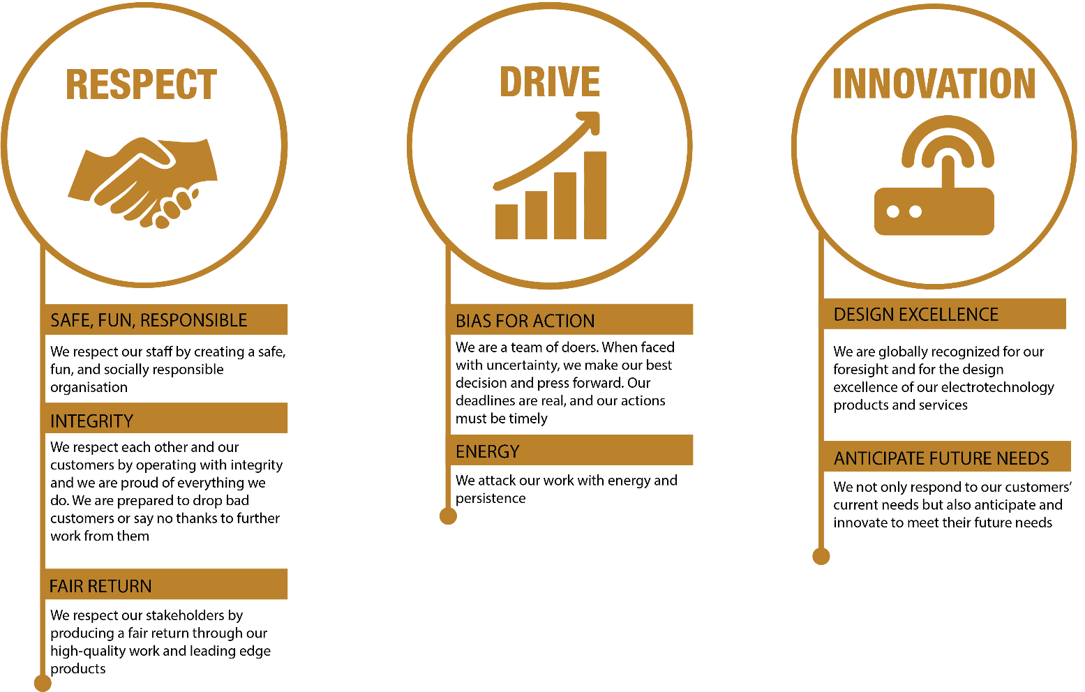

|  |  |  |  |  |
| --- | --- | --- | --- | --- |
| **REVIEWED BY:** |  |  | **DATE:** |  |
|  |  |  |  |  |
| **Last updated by:** | People and Culture |  | **Date/Time:** | Nov 23 |