Job description
Title | Electrical Engineer
Location
Start Date
Reports To
Reviewed By | Firstname Lastname | Date: | Month, 2025
Last Updated By | People & Culture | Date: | Month, 2025
Purpose:
To plan, execute, and successfully complete electrical projects.




Role Summary
McKay is proud to stand as Aotearoa, New Zealand’s largest privately owned electrotechnology provider, offering innovative electrical engineering and construction services nationwide.
Having started providing electrotechnology services in 1936, McKay is a historic New Zealand electrical company with a depth of experience in providing end to end electrical solutions for a wide range of industries and sectors. McKay is the parent brand and has acquired and started a range of companies under the McKay Group name to serve all electrical needs.
As an Electrical Engineer at McKay Ltd., you will play a crucial role in the planning, execution, and successful completion of electrical projects. This will require from you a combination of technical expertise, project management skills, and a deep understanding of electrical systems.

Responsibilities

Project Planning and Design
  - Conduct feasibility studies and assess project requirements.
  - Develop electrical system designs and plans.
  - Calculate load requirements and design electrical circuits and systems.
  - Select appropriate components, equipment, and materials.

Regulatory Compliance
  - Ensure that electrical designs and installations comply with local, state, and national electrical codes and regulations.
  - Obtain necessary permits and approvals for the project.

Budget and Resource Management
  - Prepare and manage project budgets, including cost estimation and tracking.
  - Procure materials, equipment, and subcontractors.
  - Monitor and control project costs.

Project Execution
  - Oversee the installation, testing, and commissioning of electrical systems.
  - Ensure that work is executed on time and within budget.
  - Address any technical issues or challenges that arise during the project.

Quality Assurance and Safety
  - Implement quality control measures to ensure the highest standards in electrical work.
  - Promote and enforce safety practices and guidelines to minimise risks and accidents on the job site.

Documentation and Reporting
  - Maintain accurate project records, including drawings, specifications, and change orders.
  - Generate progress reports and communicate project status to stakeholders.

Team Collaboration
  - Coordinate with project managers, electricians, technicians, and subcontractors to ensure smooth project execution.
  - Foster teamwork and collaboration among team members.

Client Interaction
  - Act as the main point of contact for clients, addressing their concerns and providing regular project updates.
  - Ensure client satisfaction and manage client expectations.

Troubleshooting and Problem Solving
  - Identify and resolve technical issues or obstacles that may arise during the project.
  - Make informed decisions to keep the project on track.

Continuous Learning
  - Stay up-to-date with advancements in electrical technology and industry best practices.
  - Attend relevant training and professional development opportunities.

Qualifications & Knowledge
- Bachelor's degree in Electrical Engineering or a related field.
- Professional Engineer (PE) licence.
- Previous experience in electrical project engineering or related roles.

Role Profile
As a Project Engineer at McKay Ltd., you must hold the following capabilities;
- Proficiency in electrical design software and project management tools.
- Strong understanding of electrical codes, standards, and regulations.
- Excellent communication and interpersonal skills.
- Strong problem-solving and decision-making abilities.
- Attention to detail and a commitment to safety.
- Ability to work both independently and as part of a team.
- Project management certification (e.g., PMP) is a plus.

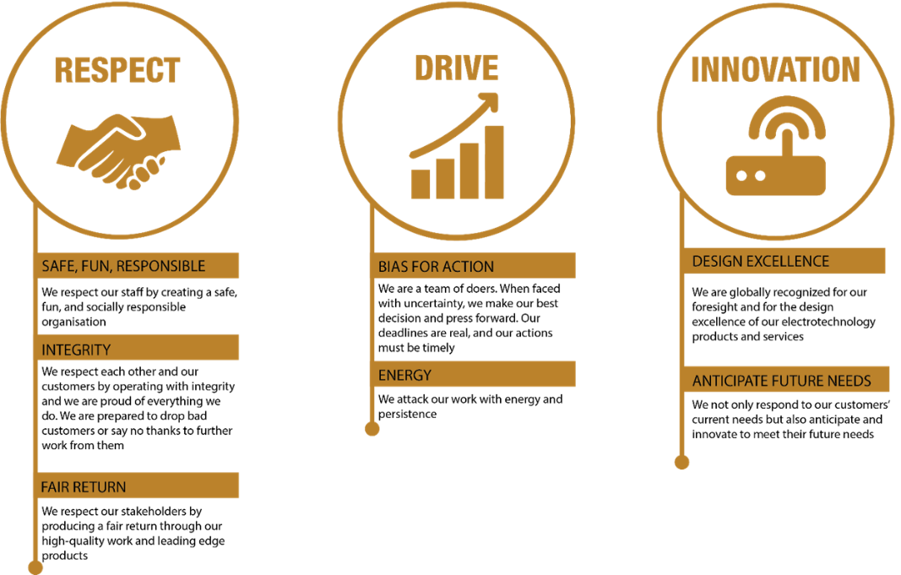
McKay Guiding Values

