Job description
Title | Renewable Energy Partnerships Manager
Location | Auckland
Start Date | February 2026
Reports To | Renewables Manager
 | Strategy & Innovation/Renewables
Reviewed By | Andrew Lancaster | Date: | January 2026
Last Updated By | People & Culture | Date: | January 2026
Purpose:
To strengthen existing relationships and identify new opportunities with strategic clients in the rapidly expanding renewable energy sector.




Role Summary
McKay is proud to stand as Aotearoa, New Zealand’s largest privately owned electrotechnology provider, offering innovative electrical engineering and construction services nationwide.
Having started providing electrotechnology services in 1936, McKay is a historic New Zealand electrical company with a depth of experience in providing end to end electrical solutions for a wide range of industries and sectors. McKay is the parent brand and has acquired and started a range of companies under the McKay Group name to serve all electrical needs.
The Renewable Energy Partnerships Manager is the primary commercial interface between our company and our most significant clients in the renewable energy sector. This role is responsible for identifying and qualifying opportunities, managing the end-to-end bid and tender process, and nurturing long-term partnerships. You will ensure that our proposals are not just technically sound but are strategically messaged to win work and meet the specific needs of our key accounts.

Responsibilities
Key Account Management & Partnerships
  - Relationship Ownership: Serve as the primary point of contact for a portfolio of strategic clients (Developers, EPCs, and Utilities).
  - Account Planning: Develop and execute "Account Roadmaps" that identify upcoming projects, key decision-makers, and white-space opportunities within our client organizations.
  - Client Advocacy: Act as the "voice of the customer" internally, ensuring our service delivery and innovation efforts align with what the market is demanding.
Tender & Bid Preparation
  - Bid preparation: Alongside our Bid Manager, lead the Renewable Energy team’s effort (including the Estimator, Engineers, and delivery specialists) to produce high-quality, persuasive tender submissions.
  - Proposal Writing: Own the "non-technical" sections of the bid—crafting the executive summary, value proposition, and delivery methodology narratives.
  - Deadline Management: Manage the tender calendar, ensuring all milestones are met and that the final submission is polished, compliant, and professional.

Market Intelligence & Business Development
  - Pipeline Management: Maintain an accurate and up-to-date CRM/Pipeline of future opportunities, providing the Renewable Energy Sector Lead with visibility into future revenue.
  - Competitor Analysis: Monitor the "moves" of other electrical contractors in the space—their pricing strategies, partnership models, and service offerings.
  - Industry Presence: Attend key sector events, conferences, and networking functions to maintain a high profile for the brand.

Account Delivery Interface & Feedback Loop
  - Post-Award Account Management: Act as the ongoing commercial account manager for awarded renewable energy projects, maintaining senior-level client relationships throughout delivery.
  - Delivery Interface: Work alongside Project Managers to ensure client expectations set during tender are understood and upheld, without duplicating project management responsibilities.
  - Client Feedback Capture: Proactively gather client feedback during and after project delivery to understand performance, value drivers, and areas for improvement.
  - Continuous Improvement: Translate delivery outcomes, lessons learned, and client feedback into tangible improvements in future bids, pricing strategies, risk allowances, and partnership models.
  - Information Flow: Ensure structured information flow from live projects back into the Renewable Energy team to inform market positioning and future opportunity targeting.

Qualifications & Knowledge
  - 5+ years’ Experience in a Partnership, Business Development, Key Account Management, or Bid Management role within Electrical Construction, Infrastructure, or Renewables.

Role Profile
As a Renewable Energy Partnerships Manager at McKay Ltd., you must hold the following capabilities;
- Strong understanding of how electrical projects are delivered.
- Demonstrated ability to build meaningful partnerships with key clients.
- Expert level proficiency in Microsoft Office Suite.
- Proficiency in CRM Software (Salesforce, HubSpot)
- Exceptional written and verbal communication skills.
- Ability to interpret and communicate technical jargon to clients.

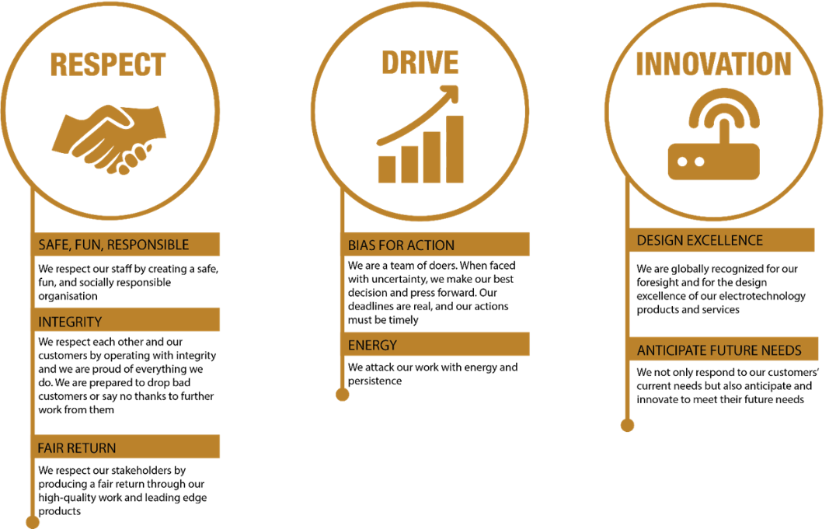
McKay Guiding Values

