JOB TITLE: | Project Manager
Location: | Bay of Plenty & Waikato |  | Date: | July 2024
Reports to: | Branch Manager or Regional Manager
Purpose: | Execution and delivery of company projects to meet specified scope, schedule, budget, and quality requirements.
ROLE SUMMARY:
Having started providing electrotechnology services in 1936, McKay is a historic New Zealand electrical company with a depth of experience in providing end to end electrical solutions for a wide range of industries and sectors. McKay is the parent brand and has acquired and started a range of companies under the McKay Group name in order to serve all electrical needs.
The overall objective for this Project Management role at McKay Ltd., is to oversee and manage the execution of various projects within McKay’s scope of work. You will play a critical role in defining project objectives, ensuring efficient resource allocation and driving project teams to achieve milestones on time and within budget. As a Project Manager, you will also be critical to the planning, execution and closing of projects, whilst maintaining a high level of client satisfaction and project quality.

RESPONSIBILITIES:

- Project Inception & Delivery
- Project initiation and set up.
- Ensure project plans are established, continually monitored and followed
- Organise resources to meet project plan.
- Oversee, monitor, and correct all material ordering procedures.
- Provide weekly data for financial progress updates and monthly reporting to company management to include risk management, resourcing, project spend etc.
- Take corrective action as required.
- Ensure project is closed out satisfactorily including as built, manuals, final cost reporting and clearance of defects liability period, retentions, and bonds.
- Ensure company assets used on the project are looked after and accounted for.

- Supervise Installation & Maintenance
- Build, lead, and motivate cross-functional project teams.
- Clearly communicate project expectations and responsibilities to team members.
- Foster a collaborative and positive team environment.

- People Management
- Set objective for each role and measure progress against objectives and take corrective action when necessary
- Supervise and organise staff to deliver services to customers
- Schedule and assign work to relevant staff, where necessary completing work personally to ensure work delivery
- Annual appraisal of direct reports
- Assess training requirements of new recruits and current staff and schedule and carry out necessary training and coaching
- Oversee staff to ensure maintenance of work site in a safe and tidy condition

- Budgetary requirements
- Obtain sign-off on and achievement of all budgetary requirements of area of responsibility e.g., material and labour requirements
- Deal with all variations as and when arising

- Communication
- Provide a realistic and timely view of project progress to the Electrical Planner Managers and other trades

- Customer Service

- Provide efficient and professional service in own area to customers
- Listen and evaluate customer needs and, when required, advise on details of time and costs arising from work
- Ensure workload allocated to staff as necessary
- Ensure relevant staff kept informed of events and issues relating to customers
- Where necessary pass on customer details to other areas of the business.

- Health & Safety
- Monitor all Health and Safety aspects on shop floor and discuss all concerns with management.
- Co-ordinate all safety meetings and ensure all areas of concern are communicated to staff and management.
- Liaiase with management on all changes to shop floor procedures and polcies.
- Implement all new shop floor procedures and policies.
- On an ongoing basis, review adherence to new procedures and policies.
QUALIFICATIONS & KNOWLEDGE:

- Applicable Project Management Diploma
or
- Applicable Electrical Engineering Degree
- Valid license to practice profession
- 5 years + work experience in major projects
ROLE PROFILE:

As a Project Manager at McKay Electrical Ltd., you must hold the following capabilities;
- Well-developed computer literacy skills, specifically with Microsoft and Project Management tools
- Solid leadership and open communication skills
- Highly developed project management skills
- Highly developed coaching skills
- Analytical and strategic thinking skills
- The ability to competently manage projects with multiple demands, priorities issues and risks.
- The ability to analyse complex technical information to provide advice to a wide range of audiences

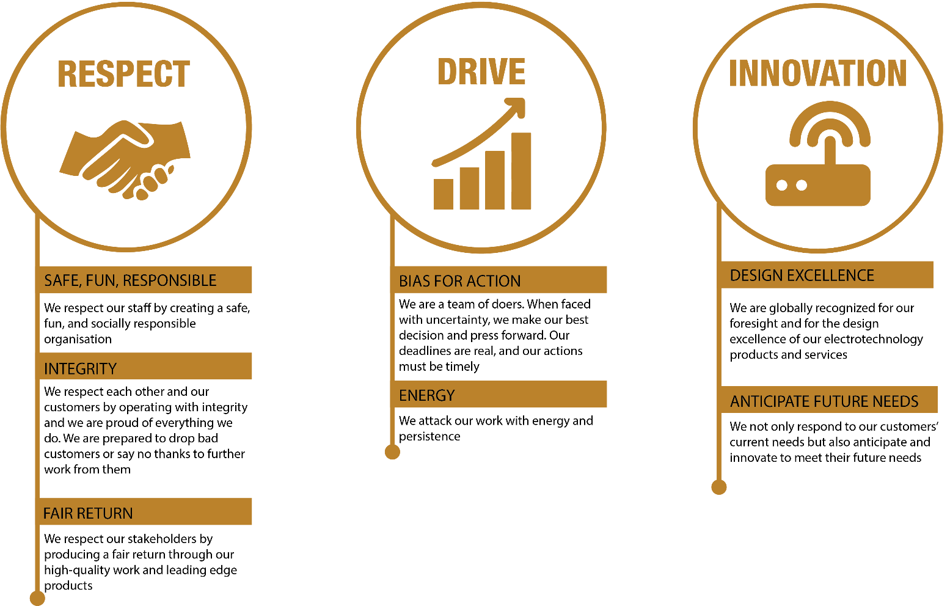

REVIEWED BY: | Carolyn Chapman |  | DATE: | July 2024
Last updated by: | People and Culture |  | Date/Time: | July 2024

