|  |  |  |  |  |
| --- | --- | --- | --- | --- |
|  | | | | |
| **JOB TITLE:** | Maintenance Manager | | | |
|  |  |  |  |  |
| Location: | Hamilton |  | Date: | August 2025 |
|  |  |  |  |  |
| Reports to: | Branch Manager | | | |
|  |  |  |  |  |
| Purpose: | Lead and support the team to deliver maintenance while enabling growth into wider industrial markets. | | | |
|  |  |  |  |  |
| **ROLE SUMMARY:** | | | | |
| As the Hamilton Maintenance Manager at McKay Ltd, you will lead and support our maintenance team, with a primary focus on delivering reliable and efficient services for the three waters sector. Your role will involve business development, coordinating and overseeing all maintenance activities for electrical systems and equipment, ensuring performance, safety, and reliability. You will drive preventive maintenance programs, support and develop your team, and position the business for growth into wider maintenance opportunities as demand and capability expand.  You will work closely with installation teams, estimators, and clients to ensure maintenance contracts are delivered profitably and to a high standard. Building strong relationships and identifying opportunities for new work will be key, as will fostering a culture of safety, quality, and continuous improvement within the team. | | | | |

|  |
| --- |
| RESPONSIBILITIES: |

1. **Team Leadership:**
   * Lead and manage a team of maintenance technicians, providing guidance, training, and support.
   * Foster a safety-conscious and collaborative work environment.
2. **Relationship Management**
   * Establish and nurture strong, trust-based relationships with clients
   * Deliver exceptional service and support to enhance client satisfaction.
   * Collaborate with internal teams to ensure client requirements and met.
3. **Maintenance Planning and Scheduling:**
   * Develop and implement comprehensive maintenance plans for electrical systems and equipment.
   * Schedule and coordinate routine maintenance activities to minimise downtime and disruptions to operations.
4. **Troubleshooting and Repairs:**
   * Oversee troubleshooting activities to identify and resolve electrical issues promptly.
   * Coordinate and participate in the repair and maintenance of electrical equipment and systems.
5. **Preventive Maintenance:**
   * Develop and implement preventive maintenance programs to extend the lifespan of electrical systems and reduce the likelihood of unplanned breakdowns.
   * Regularly review and update preventive maintenance procedures.
6. **Financial Management:**
   * Work closely with installation teams and estimators to ensure maintenance contracts and jobs are priced, delivered, and managed for profitability.
   * Monitor job performance and costs to maximise margin and ensure financial targets are met.
7. **Regulatory Compliance:**
   * Stay informed about relevant electrical codes, regulations, and industry standards.
   * Ensure that all maintenance activities comply with safety and regulatory requirements.
8. **Vendor Management:**
   * Collaborate with external vendors for specialised maintenance services and equipment procurement.
   * Evaluate vendor performance and negotiate contracts for maintenance services.
9. **Asset Management:**
   * Maintain accurate records of electrical assets, including equipment specifications, maintenance history, and warranties.
   * Develop strategies for asset optimization and replacement as needed.
10. **Continuous Improvement:**
    * Identify opportunities for process improvement and efficiency within the maintenance department.
    * Implement best practices to enhance overall maintenance effectiveness.
11. **Emergency Response:**
    * Develop and implement emergency response plans for electrical failures or incidents.
    * Coordinate with other departments to ensure a swift and effective response to critical situations.

|  |
| --- |
| QUALIFICATIONS & KNOWLEDGE: |

* New Zealand Registered Electrician, familiar with relevant industry codes and regulations.
* Proven track record of leadership and team management with excellent communication and organisational skills.
* Several years of experience in electrical maintenance.
* Water industry experience of benefit.
* Experience in new business development and growth would be beneficial

|  |
| --- |
| McKay GUIDING VALUES: |

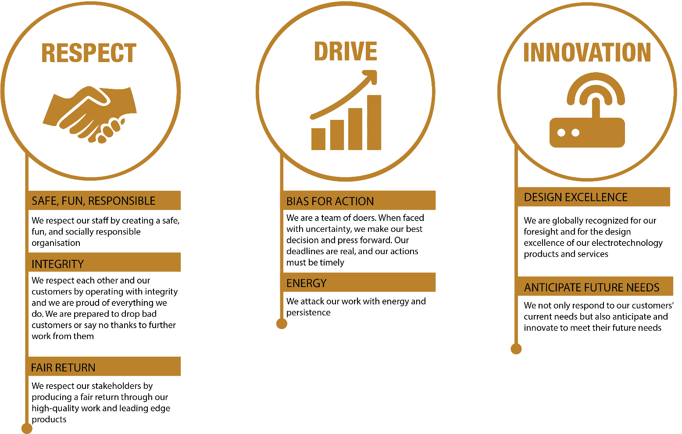

|  |  |  |  |  |
| --- | --- | --- | --- | --- |
| **REVIEWED BY:** |  |  | **DATE:** |  |
|  |  |  |  |  |
| **Last updated by:** | SA |  | **Date/Time:** | 29/7/25 |