Job description
Title | Automation Engineer
Location | Whangarei
Start Date | tbc
Reports To | Andreas Zaugg
Reviewed By | James Hand | Date: | March, 2025
Last Updated By | People & Culture | Date: | Month, 2025
Purpose:
To optimise operations, enhance efficiency, and ensure the reliability of electrical systems through automation.
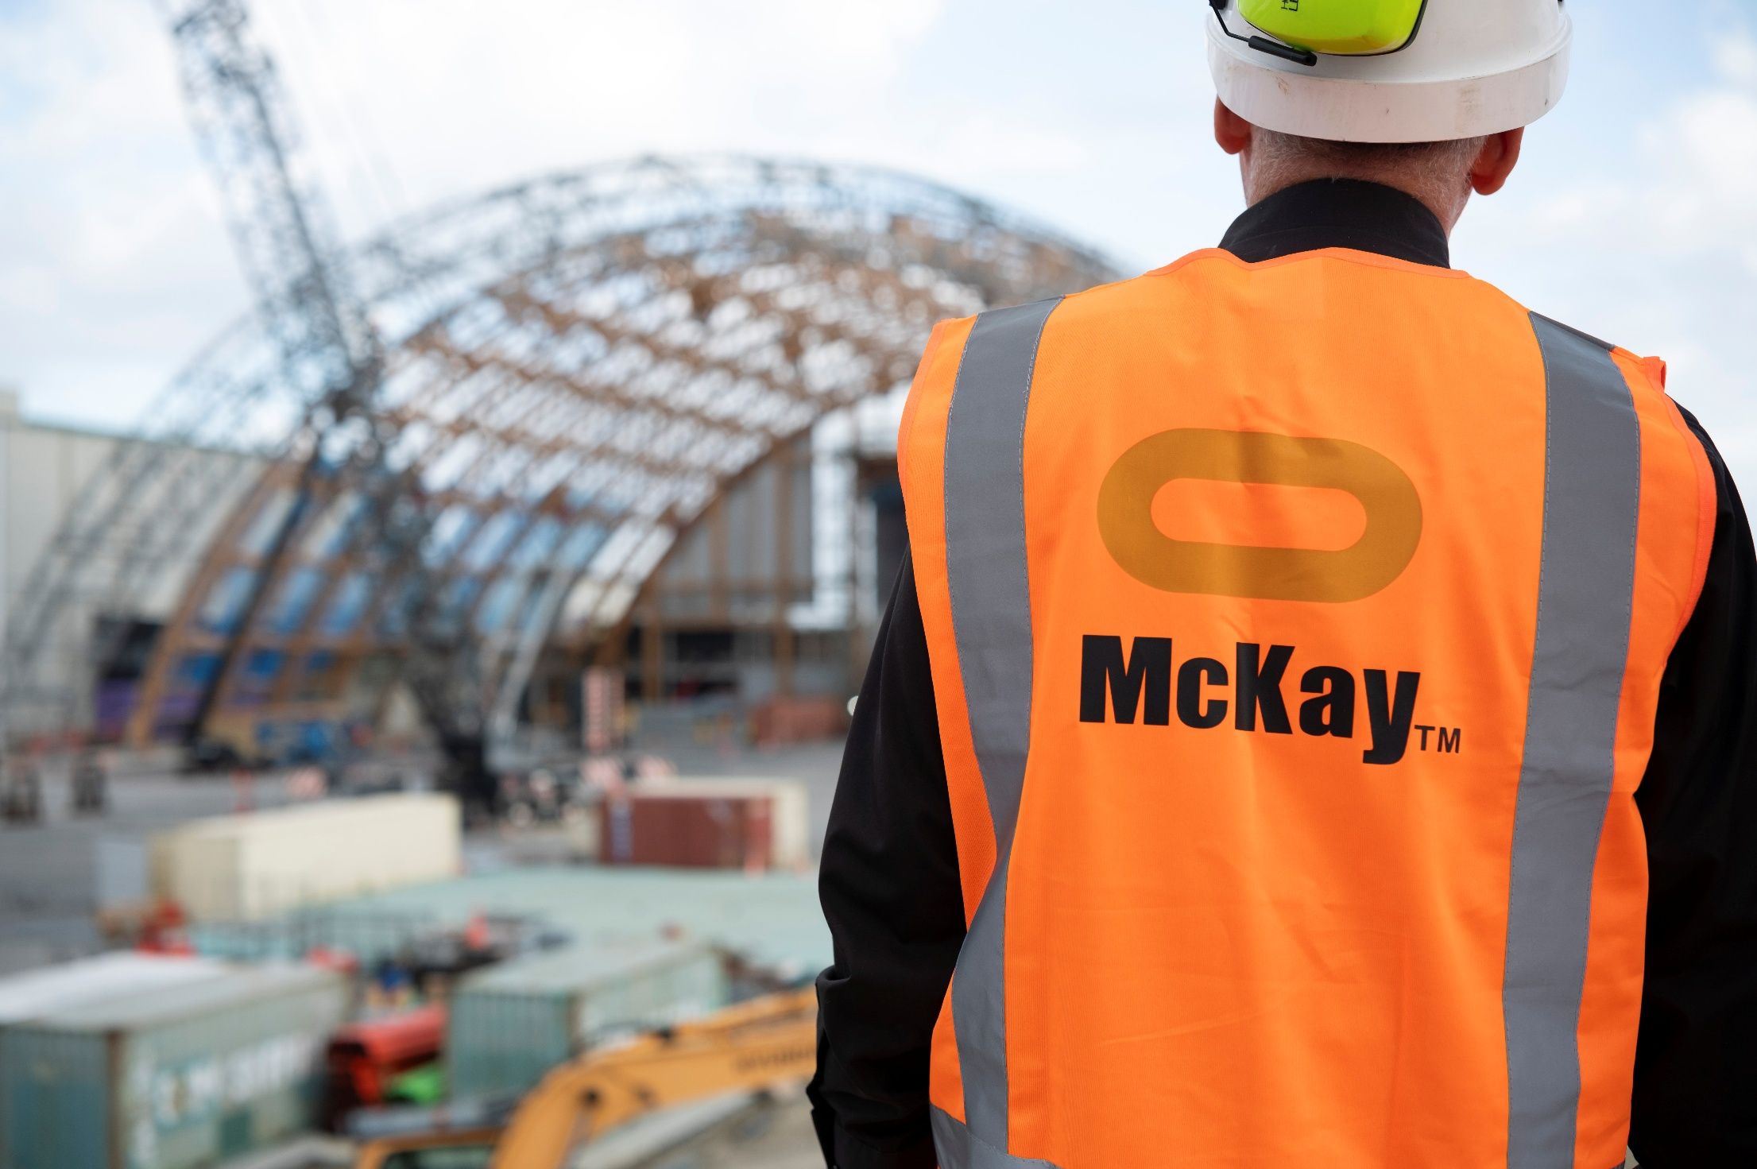



Role Summary
McKay is proud to stand as Aotearoa, New Zealand’s largest privately owned electrotechnology provider, offering innovative electrical engineering and construction services nationwide.
Having started providing electrotechnology services in 1936, McKay is a historic New Zealand electrical company with a depth of experience in providing end to end electrical solutions for a wide range of industries and sectors. McKay is the parent brand and has acquired and started a range of companies under the McKay Group name to serve all electrical needs.
As an Automation Engineer at McKay Electrical Ltd., you play a crucial role in designing, developing, and maintaining automated systems and processes that involve electrical components and control systems. The primary focus of your work is to optimise operations, enhance efficiency, and ensure the reliability of electrical systems through automation.

Responsibilities
System Design
- Design and develop automated control systems for various electrical applications, including manufacturing, power distribution, and process control.
PLC and HMI Programming
- Develop and implement Programmable Logic Controller (PLC) and Human-Machine Interface (HMI) software to control electrical equipment and monitor system performance.
Sensor Integration
- Integrate sensors and instrumentation to collect data and provide feedback for control systems.
Control Panel Design
- Design and configure control panels, including selecting appropriate components, wiring, and assembly.
Troubleshooting
- Identify and resolve electrical and automation system issues, which may include debugging software, troubleshooting hardware, and diagnosing communication problems.
Testing and Commissioning
- Perform system testing, validation, and commissioning to ensure proper functionality, safety, and compliance with industry standards.
Maintenance
- Develop and implement maintenance plans to keep automation systems operational and updated, including software upgrades and hardware replacements.
Documentation
- Maintain accurate records, documentation, and schematics for all control systems and automation components.
Safety Compliance
- Ensure that all automation systems meet safety regulations and standards and implement safety protocols in the design and operation of systems.
Collaboration
- Work closely with electrical engineers, technicians, and other professionals to achieve project goals and maintain smooth operations.
Continuous Improvement
- Identify opportunities for process improvement, cost reduction, and system optimisation and implement solutions accordingly.

Qualifications & Knowledge
- A degree in Electrical Engineering, Automation, or a related field. A Master's degree may be preferred for more complex roles.

Role Profile
As an Automation Engineer at McKay Electrical Ltd., you should have the following capabilities;
- Strong knowledge of electrical systems, control systems, and automation technology.
- Proficiency in PLC programming languages (e.g., ladder logic, structured text) and HMI software.
- Familiarity with various automation protocols.
- Knowledge of electrical codes and safety standards.
- Strong problem-solving and troubleshooting skills.
- Experience with CAD software for control panel design.
- Excellent communication and teamwork skills.
- Experience in project management and automation project life cycles.
- Adaptability to stay updated on the latest automation technologies and industry trends.

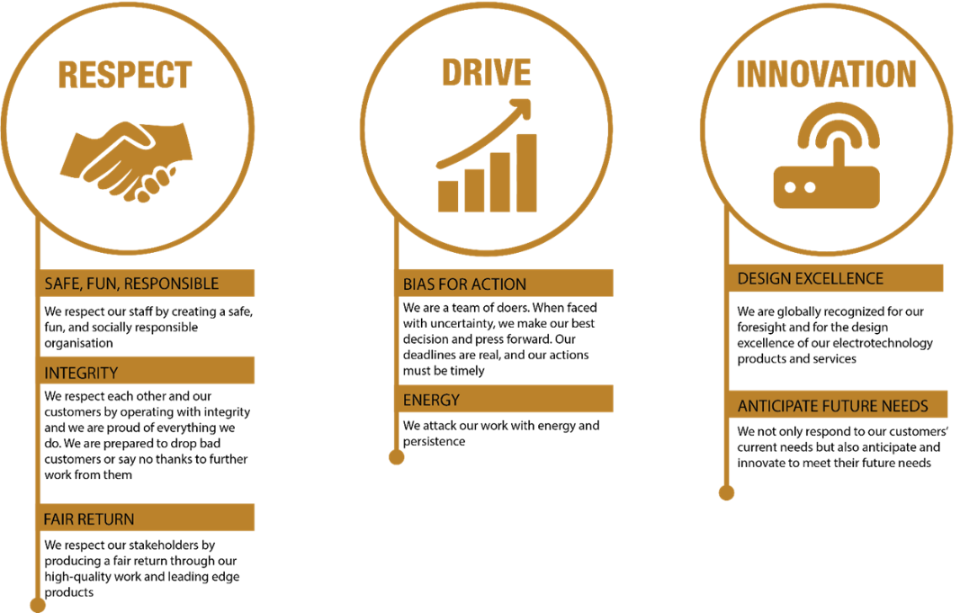
McKay Guiding Values

