|  |  |  |  |  |
| --- | --- | --- | --- | --- |
|  | | | | |
| **JOB TITLE:** | Construction Manager | | | |
|  |  |  |  |  |
| Location: |  |  | Date: |  |
|  |  |  |  |  |
| Reports to: |  | | | |
|  |  |  |  |  |
| Purpose: | To oversee all onsite installations and to monitor compliance with electrical and safety regulations | | | |
|  |  |  |  |  |
| **ROLE SUMMARY:** | | | | |
| Having started providing electrotechnology services in 1936, McKay is a historic New Zealand electrical company with a depth of experience in providing end to end electrical solutions for a wide range of industries and sectors. McKay is the parent brand and has acquired and started a range of companies under the McKay Group name in order to serve all electrical needs.  As the Construction Manager at McKay Limited, you will oversee direct electrical installation projects from initiation to completion daily reviews of productivity, review the project monitor schedule deliverables and estimated costs. You will also be responsible for overseeing all onsite installation and to monitor compliance with electrical and safety regulations. | | | | |

|  |
| --- |
| RESPONSIBILITIES: |

**1. Project Planning & Execution**

* Oversee and direct electrical installation productivity from conception to completion.
* Review the project schedule deliverables and estimate costs, including reducing overtime and ensuring high productivity.
* Meet contractual conditions of performance.
* Plan to prevent problems and resolve any emerging issues.
* Ability to plan and see the “big picture”.
* Ensuring the installation process starts and ends on time, and ensuring daily and weekly deadlines are met.

**2. Team Leadership & Human Resource Management**

* Assist supervisors to coordinate and direct workers and subcontractors to ensure productivity.
* Managing and motivating site supervisors and teams.
* Leadership and human resources management skills – deal with poor performance.
* Manage poor site attendance with site supervisor and escalate unacceptable staff behaviour with respect to attendance.
* Competent in conflict and crisis management.

**3. Coordination & Communication**

* Meeting with engineers, architects, and contractors on an ongoing basis regarding project objectives and progress.
* Understanding and support SI's and VOs to project management.

**4. Risk & Issue Management**

* Analyse, manage and mitigate risks with site supervisor.
* Review the work progress on daily basis – site supervisor to track.

**5. Quality Assurance & Compliance**

* Ensure quality installation standards and the use of proper installation techniques.
* Conducting ongoing quality inspections.
* Ensuring compliance with health, safety, and all other regulations.
* Relevant ITPs, test sheets, COCs, document management inspection suite of qualityverification sheets for a plan to be created by Construction Manager.

**6. Technical Knowledge & Expertise**

* Proven working experience in electrical installation management.
* Advanced knowledge of electrical installation management processes, means and methods.
* Expert knowledge of products, installation details, and relevant rules, regulations and quality standards.
* Understanding of all facets of the installation process.

**7. Resource & Inventory Management**

* Select tools, materials and equipment and track inventory. Review with general manager any needs or recommendations.
* Ensuring all equipment needed is available on site, review with General Manager / Project Manager.

**8. Budget & Cost Control**

* Ensuring budget hours, contractors, materials, and equipment aren’t exceeded.
* Excellent time and project management skills.

|  |
| --- |
| QUALIFICATIONS & KNOWLEDGE: |

* Engineering Degree or equivalent experience
* Tech savvy and able to learn and utilize new technologies

|  |
| --- |
| ROLE PROFILE: |

As the Construction Manager at McKay Ltd., you must hold the following capabilities.

* Proven experience in leadership.
* Ability to organize a daily workload by priorities.
* Must be able to meet deadlines in a fast-paced, quickly changing environment.
* A proactive approach to problem-solving with strong decision-making skills.
* Professional level verbal and written communications skills.
* Used to operating in a highly confidential environment.
* Proven relationship building skills

|  |
| --- |
| McKay GUIDING VALUES: |

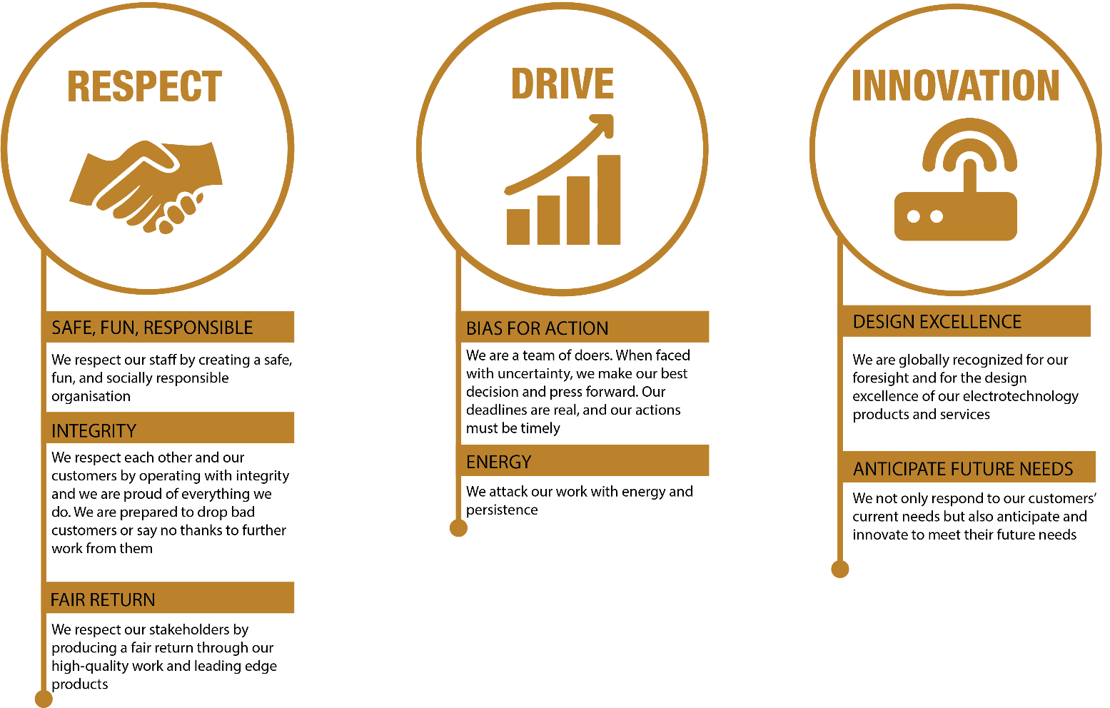

|  |  |  |  |  |
| --- | --- | --- | --- | --- |
| **REVIEWED BY:** |  |  | **DATE:** |  |
|  |  |  |  |  |
| **Last updated by:** | People and Culture |  | **Date/Time:** | May 2025 |