|  |  |  |  |  |
| --- | --- | --- | --- | --- |
|  | | | | |
| **JOB TITLE:** | Electrician | | | |
|  |  |  |  |  |
| Location: |  |  | Date: |  |
|  |  |  |  |  |
| Reports to: |  | | | |
|  |  |  |  |  |
| Purpose: | To be responsible for the installation, maintenance, and repair of electrical systems and equipment. | | | |
|  |  |  |  |  |
| **ROLE SUMMARY:** | | | | |
| Having started providing electrotechnology services in 1936, McKay is a historic New Zealand electrical company with a depth of experience in providing end to end electrical solutions for a wide range of industries and sectors. McKay is the parent brand and has acquired and started a range of companies under the McKay Group name in order to serve all electrical needs.  As an Electrician at McKay Electrical Ltd., you are a skilled tradesperson responsible for the installation, maintenance, and repair of electrical systems and equipment. You will work in a variety of settings, from residential homes and commercial buildings to industrial facilities. They ensure that electrical systems are safe, reliable, and in compliance with relevant codes and regulations. | | | | |

|  |
| --- |
| RESPONSIBILITIES: |

1. **Electrical Installation:**
   * Install wiring, electrical panels, outlets, and fixtures in new construction and renovation projects.
   * Determine the appropriate placement and layout of electrical components.
   * Connect wiring to transformers, circuit breakers, or other components.
2. **Maintenance and Repair:**
   * Troubleshoot electrical problems to identify faults and issues.
   * Repair or replace damaged or outdated electrical components, such as switches, outlets, and fixtures.
   * Perform routine maintenance to prevent electrical system failures.
3. **Compliance and Safety:**
   * Ensure all electrical work adheres to local, state, and national electrical codes.
   * Inspect electrical systems to identify potential safety hazards and rectify them.
   * Follow safety protocols and guidelines to minimise electrical risks.
4. **Reading Blueprints and Technical Documents:**
   * Interpret blueprints, technical diagrams, and schematics to plan and execute electrical installations.
   * Review specifications to ensure compliance with project requirements.
5. **Equipment and Tool Management:**
   * Maintain and repair tools and equipment used in electrical work.
   * Keep tools and equipment in good working condition, following safety guidelines.
6. **Customer Communication:**
   * Communicate with customers to understand their electrical needs and provide cost estimates for projects.
   * Explain the work performed and educate customers about electrical safety.
7. **Up-to-Date Knowledge:**
   * Stay informed about advancements in electrical technology, regulations, and safety standards.
   * Participate in ongoing training and professional development to enhance skills.
8. **Documentation:**
   * Create and maintain records of electrical work performed, including wiring diagrams, maintenance logs, and repair reports.
   * Submit necessary documentation for permits and inspections.

|  |
| --- |
| QUALIFICATIONS & KNOWLEDGE: |

* Completion of an electrical apprenticeship program or relevant vocational training.
* Appropriate national electrician's license

|  |
| --- |
| ROLE PROFILE: |

As an Electrician at McKay Electrical Ltd., you must hold the following capabilities;

* Strong knowledge of electrical codes and regulations.
* Proficiency in reading blueprints and technical diagrams.
* Excellent problem-solving and troubleshooting skills.
* Physical stamina and the ability to work in various environments, including confined spaces.
* Strong attention to detail and safety-conscious.
* Good communication and customer service skills.
* Basic computer skills for recordkeeping and communication.

|  |
| --- |
| McKay GUIDING VALUES: |

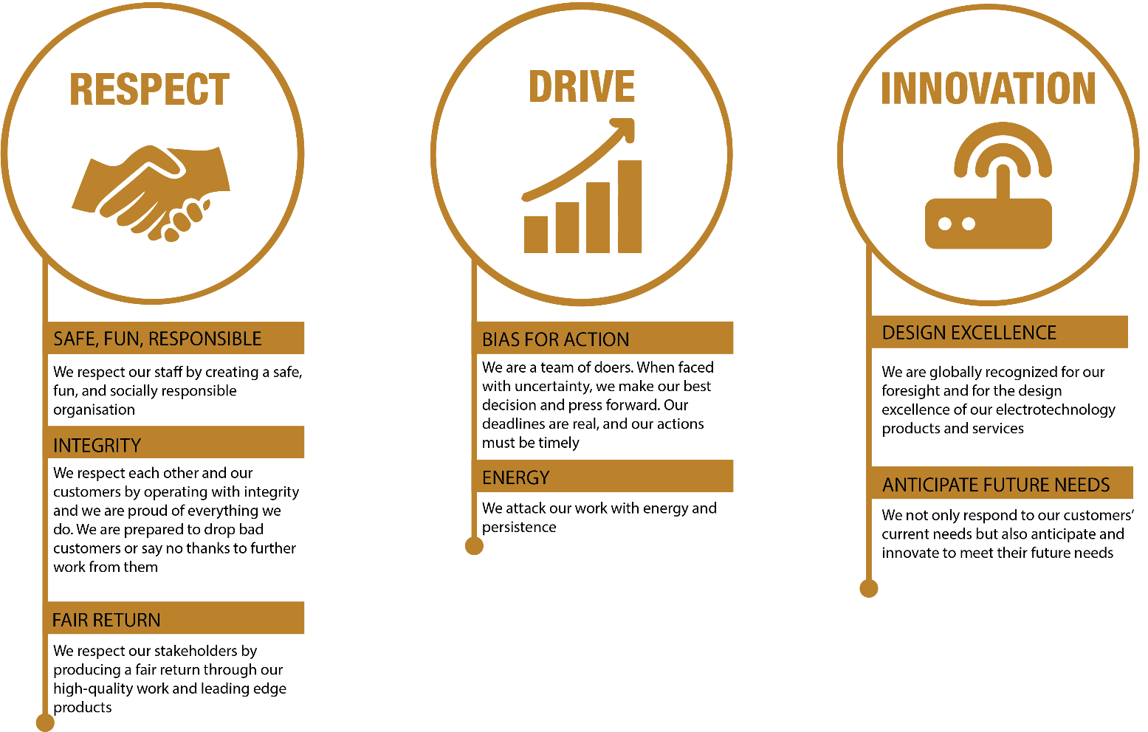

|  |  |  |  |  |
| --- | --- | --- | --- | --- |
| **REVIEWED BY:** |  |  | **DATE:** |  |
|  |  |  |  |  |
| **Last updated by:** | People and Culture |  | **Date/Time:** | Nov 23 |