|  |  |  |  |  |  |
| --- | --- | --- | --- | --- | --- |
|  | | | | | |
| **JOB TITLE:** | Regional Manager – Lower South Island | | | |
|  |  |  |  |  |
| Location: | Queenstown Branch, Cromwell |  | Date: | 1 April 2025 |
|  |  |  |  |  |
| Reports to: | Executive General Manager | | | |
|  |  |  |  |  |
| Purpose: | To drive the growth and expansion of the branch by overseeing daily operations, leading the team to achieve business objectives, and implementing strategies to enhance customer engagement and market presence. | | | |
|  |  |  |  |  |
| **ROLE SUMMARY** | | | | |
| McKay is proud to stand as New Zealand’s largest privately owned electrotechnology provider, offering innovative electrical engineering, construction and maintenance services nation-wide. McKay is recognised as a sought-after specialist in the electrical industry, with a renowned reputation for delivering collaborative, high-quality and innovative electrical solutions across a range of sectors including Infrastructure, Industrial, Construction, Renewables, and Marine.  Established in Northland in 1936, McKay’s roots have remained grounded in its Northland heritage, with its headquarters proudly located in Whangārei, and operates seamlessly through its 11 branches throughout New Zealand and its growing presence in the South Pacific and United States.  As Branch Manager at McKay, you will be responsible for overseeing the day-to-day operations of the branch, ensuring efficient and effective functioning of the team, and driving business growth in the region. This position requires strong leadership and B2B business development and/or sales skills, in-depth knowledge of electrical products and services, and the ability to manage both people and resources. | | | | |

|  |
| --- |
| RESPONSIBILITIES |

1. **Leadership and Team Management:**
   * Provide motivational leadership to the team, fostering a positive and collaborative work environment.
   * Lead the team to achieve individual and collective goals.
   * Conduct regular team meetings to communicate goals, performance expectations, and updates.
   * Develop and encourage diversity and inclusion across the team.
   * Allocate resources efficiently, including personnel, equipment, and materials, to ensure team milestones are achieved.
   * Lead by example, do what you say you will do and take a highly proactive, solutions focussed approach to the role.
   * Bring the company values of Respect, Drive and Innovation to life through your leadership style and approaches.
   * Be a collaborative leader where internal relationships are maintained.
2. **Operational Excellence:**
   * Oversee the daily operations of the team, ensuring adherence to company policies and procedures.
   * Oversee the execution of projects, ensuring adherence to quality standards, safety regulations, and industry best practices.
   * Implement and maintain safety protocols to ensure a secure working environment.
   * Foster a culture where delivering projects to a high quality and safety standard are core team values.
   * Ensure that all documentation and processes are delivered to a high level and that this standard is achieved at all levels within your team.
3. **Customer Service:**
   * Develop and maintain strong customer relationships to achieve high levels of customer satisfaction and loyalty.
   * Establish and maintain effective communication channels with internal and external stakeholders, including clients, contractors, and regulatory authorities.
   * Resolve customer complaints and issues promptly, ensuring a high level of customer service.
4. **Sales and Business Development:**
   * Identify and pursue new business opportunities within the assigned region and nationally as required.
   * Closely collaborate with the Business Development and Marketing Team to develop annual business plans which you take ownership and accountability for.
   * You are responsible for a continuous flow of projects with an overall expectation that there will be revenue and profit growth year on year.
   * Use available research and analysis to identify potential opportunities within the region.
   * Seek opportunities for upselling and cross-selling.
   * Accountable for management of bid and tender process ensuring that bids and tenders are always to a highly professional and best practice standard.
   * Analyse market trends and customer needs to develop effective sales strategies.
5. **Financial Management:**
   * Monitor and manage project and business unit budget, forecasting, expenses, and financial performance.
   * Implement cost-control measures to maximise profitability.
   * Prepare and analyse financial reports for senior management.
6. **Training and Development:**
   * Identify training needs within the team and coordinate training programs accordingly.
   * Foster a culture of continuous learning and development. Provide monthly 1-2-1’s for direct reports to monitor on the job learning and progress towards career and role goals.
   * Conduct performance reviews and provide ongoing coaching, including creating individual development plans to support career growth and succession planning for McKay and the business unit.
   * Nurture key talent and proactively manage poor performance as it occurs.

|  |
| --- |
| QUALIFICATIONS & KNOWLEDGE |

* Bachelor's degree (or equivalent) in Business Administration, Project Management, Engineering, or a related field.
* Proven experience in a leadership role

|  |
| --- |
| ROLE PROFILE: |

As a Branch Manager at McKay Ltd., you must hold the following capabilities;

* High level of professionalism
* Strong knowledge of electrical products, systems, and industry trends
* High level of emotional intelligence
* Excellent and proactive leadership, communication, customer and interpersonal skills
* Experience of business to business sales and business development
* Ability to make sound decisions under pressure and adapt to changing circumstance.
* Budget and financial management
* High level of knowledge of application of project management methodologies and systems
* Proficient in Microsoft Office Suite and other relevant business software.

|  |
| --- |
| McKay GUIDING VALUES: |

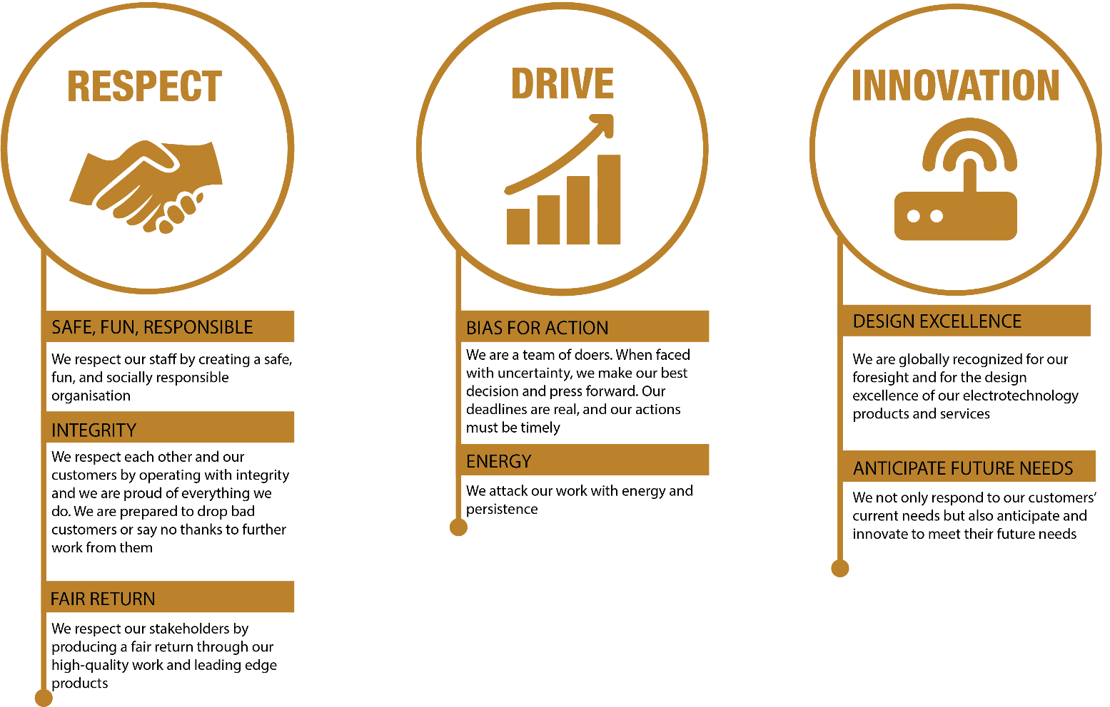

|  |  |  |  |  |
| --- | --- | --- | --- | --- |
| **REVIEWED BY:** |  |  | **DATE:** |  |
|  |  |  |  |  |
| **Last updated by:** | Executive General Manager, Regions |  | **Date/Time:** | 7 April 2025 |