|  |  |  |  |  |
| --- | --- | --- | --- | --- |
|  | | | | |
| **JOB TITLE:** | Supervisor (Electrical Projects) | | | |
|  |  |  |  |  |
| Location: |  |  | Date: |  |
|  |  |  |  |  |
| Reports to: |  | | | |
|  |  |  |  |  |
| Purpose: | To oversee and coordinate the electrical activities within the company’s electrical projects division. | | | |
|  |  |  |  |  |
| **ROLE SUMMARY:** | | | | |
| Having started providing electrotechnology services in 1936, McKay is a historic New Zealand electrical company with a depth of experience in providing end to end electrical solutions for a wide range of industries and sectors. McKay is the parent brand and has acquired and started a range of companies under the McKay Group name in order to serve all electrical needs.  As a Supervisor (Electrical Projects) at McKay Electrical Ltd., you will play a crucial role in overseeing and coordinating the electrical activities with the company’s electrical projects division. This role involves supervising a team of electricians, ensuring that electrical systems and equipment are installed, maintained, and repaired efficiently and in compliance with safety and regulatory standards. | | | | |

|  |
| --- |
| RESPONSIBILITIES: |

1. **Supervision and Leadership:**
   * Lead and manage a team of electricians, providing guidance, direction, and support.
   * Assign tasks, set priorities, and ensure that team members adhere to schedules and deadlines.
   * Conduct regular team meetings to communicate goals, expectations, and updates.
2. **Project Planning and Coordination:**
   * Collaborate with project managers to plan and coordinate electrical work in line with project timelines.
   * Review project specifications and blueprints to determine electrical requirements.
   * Develop work schedules and allocate resources effectively.
3. **Installation and Maintenance:**
   * Oversee the installation, maintenance, and repair of electrical systems, equipment, and components.
   * Ensure that work is carried out in compliance with relevant codes, regulations, and safety standards.
   * Troubleshoot electrical issues and provide technical expertise to resolve problems.
4. **Quality Assurance:**
   * Conduct regular inspections to ensure the quality of electrical workmanship.
   * Implement and enforce quality control measures to meet industry standards.
   * Address and rectify any deviations from established standards.
5. **Budget Management:**
   * Assist in the development of electrical project budgets.
   * Monitor expenses, control costs, and ensure that projects are completed within budgetary constraints.
6. **Training and Development:**
   * Identify training needs for team members and coordinate relevant training programs.
   * Foster a culture of continuous learning and skill development within the electrical team.
7. **Documentation and Reporting:**
   * Maintain accurate records of electrical work, including project documentation and reports.
   * Provide regular progress reports to management and stakeholders.
8. **Safety Compliance:**
   * Enforce and promote a strong safety culture among the electrical team.
   * Ensure that all electrical work is conducted in accordance with safety regulations and best practices.

|  |
| --- |
| QUALIFICATIONS & KNOWLEDGE: |

* Bachelor’s degree in Electrical Engineering or a related field.
* Proven experience in electrical supervision.

|  |
| --- |
| ROLE PROFILE: |

As a Supervisor (Electrical Projects) at McKay Electrical Ltd., you must hold the following capabilities;

* Knowledge of electrical codes, regulations, and industry best practices.
* Strong leadership and communication skills.
* Ability to read and interpret blueprints and technical drawings.
* Proficient in the use of relevant electrical tools and equipment.

|  |
| --- |
| McKay GUIDING VALUES: |

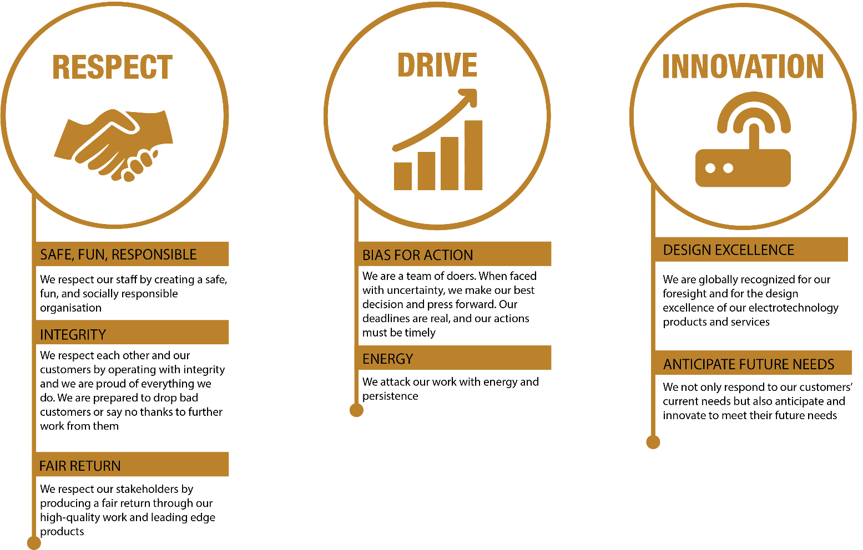

|  |  |  |  |  |
| --- | --- | --- | --- | --- |
| **REVIEWED BY:** |  |  | **DATE:** |  |
|  |  |  |  |  |
| **Last updated by:** | People and Culture |  | **Date/Time:** | Nov 23 |