JOB TITLE: | Senior Renewables Engineer
Location: | Penrose, Auckland |  | Date: | March 2024
Reports to: | Renewables Manager
Purpose: | To lead the technical aspects relating Renewable Energy Projects including steering the design to be constructable, meet the required technical standards, and fit the client's needs.
ROLE SUMMARY:
Having started providing electrotechnology services in 1936, McKay is a historic New Zealand electrical company with a depth of experience in providing end to end electrical solutions for a wide range of industries and sectors.
McKay’s Renewables division is on exciting journey to contribute to the decarbonisation of Aotearoa, New Zealand through design and construction of innovative Solar, BESS, and Geothermal Energy projects.
As a Senior Renewables Engineer within the team, you will play a crucial role in the planning, execution, and successful completion of electrical projects. This will require a combination of technical expertise, leadership skills, and a deep understanding of electrical systems.
Not one day will be the same. You will find yourself working on client projects, visiting sites to undertake design validation, commissioning activities, and meet with clients, and collaborating and mentoring other engineers.
Depending on your experience, and desires, you may also be involved with proposal development and responding to tenders.

RESPONSIBILITIES:

You’ll be a technical engineer who will be working across one or more Renewable Energy projects within Aotearoa. You’ll work as part of McKay’s dedicated Renewable Energy division, alongside other engineers, project managers, and occasionally the business development team.
Delivering high quality projects will be your bread and butter, and being a point of technical expertise within Renewable Energy will come as second nature to you.
- Technical Delivery of Projects:
  - Project Delivery Experience in two or more of the following fields of expertise:
    - Utility Scale Photovoltaic system design (>5MW).
    - AC Power Systems Design including load flow analysis, protection selection studies, and cable selection, including Medium Voltage Power System design up to 33kV.
    - Utility scale Battery Energy Storage Systems.
    - Electrification including transport and industrial heat applications.
  - Design-for-Construction experience.
  - Experience in technical report writing including design specifications.
  - Experience in applying Safety-I n-Design philosophies to the projects which are undertaken
  - Provide guidance to and ensure that electrical designs and installations are compliant with local, state, and national electrical codes and regulations. Where required, be comfortable applying IEC standards where a local equivalent does not exist.
  - Where required, certify designs to allow construction against Part 1 of AS/NZS3000
  - Preparation of Detailed Design Packages, Design Reports, Commissioning Documentation
- Installation and Commissioning:
  - Oversee the installation, testing, and commissioning of renewable energy electrical systems.
  - Assist electrical technicians and other personnel with fault finding of designs,
- Leadership & Mentorship
  - Demonstratable experience in mentoring and leading other engineers including through detailed design processes.
  - Capability to lead discrete technical phases of projects through the design lifecycle.
- Quality Assurance and Safety:
  - Maintain McKay’s quality control measures to ensure the highest standards in electrical work. Perform regular checks to uphold project quality.
  - Promote and enforce safety practices and guidelines to minimise risks and accidents on the job site.
- Documentation and Reporting:
  - Maintain accurate project records, including drawings, specifications, and modelling outputs.
- Team Collaboration:
  - Coordinate with other engineers, project managers, electricians, technicians, and subcontractors to ensure smooth project execution.
  - Foster teamwork and collaboration among team members.
- Client Interaction:
  - Act as a technical point of contact for clients, addressing their concerns and providing regular project updates.
  - Ensure client satisfaction and manage client expectations.
- Troubleshooting and Problem Solving:
  - Identify design trade-offs and technical risks to a specific design and ensure that these are managed to make a project successful
  - Identify and resolve technical issues or obstacles that may arise during the project.
  - Make informed decisions to keep the project on track.
- Continuous Learning:
  - Stay up to date with advancements in electrical technology and industry best practices.
  - Attend relevant training and professional development opportunities.

QUALIFICATIONS & KNOWLEDGE:
Minimum:
- Bachelor's degree in Electrical Engineering or a related field, or significant demonstrated experience in the industrial or power generation industry
- Depth of knowledge of the application of relevant AS/NZS standards (AS/NZS5033, AS/NZS4777, AS/NZS3000 etc.), and IEC standards relating to electrical installations, photovoltaic systems, BESS etc.
- Applied experience designing, and commissioning, Renewable Energy or other Industrial electrical systems
Desirable experience:
- Master's degree in Engineering with an Electrical or Renewable Energy focus
- Professional registration is preferred but not essential (CPEng or similar)
- Other industry connections within the renewable energy sector
- Grid Coordination at a Distribution and/or Transpower level
- Owner’s Engineer experience

ROLE PROFILE:
As a Senior Renewables Engineer at McKay Ltd., you should meet the following:
- A minimum of seven years of experience working within a consulting or project focused electrical engineering role in renewable energy, power generation, or a similar industrial setting i.e., oil and gas or wastewater treatment.
- A willingness to keep up to date with industry developments including new technologies and approaches.
- Strong knowledge around software tools such as ETAP for modelling power systems
- Well developed communications skills. In our business being able to successfully distil technical requirements to clients is everything!
- A willingness to mentor and develop those around you.
- A pride in providing high quality engineering deliverables to meet the needs of a client

McKay GUIDING VALUES:

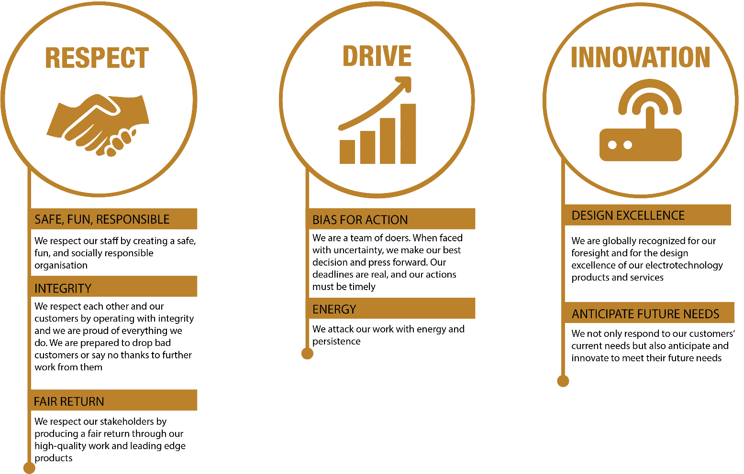

REVIEWED BY: | Carolyn Chapman |  | DATE: | March 2024
Last updated by: | Acting Renewables Manager |  | Date/Time: | Mar 24

