|  |  |  |  |  |
| --- | --- | --- | --- | --- |
|  | | | | |
| **JOB TITLE:** | Estimator | | | |
|  |  |  |  |  |
| Location: | BOP Hamilton |  | Date: | May 2025 |
|  |  |  |  |  |
| Reports to: | Regional Manager | | | |
|  |  |  |  |  |
| Purpose: | To accurately estimate the cost of electrical projects, help in the bidding process, and ensure that projects are financially viable. | | | |
|  |  |  |  |  |
| **ROLE SUMMARY:** | | | | |
| Having started providing electrotechnology services in 1936, McKay is a historic New Zealand electrical company with a depth of experience in providing end to end electrical solutions for a wide range of industries and sectors. McKay is the parent brand and has acquired and started a range of companies under the McKay Group name in order to serve all electrical needs.  The role of Estimator plays a crucial role in our organisation by accurately estimating the cost of electrical projects, helping in the bidding process, and ensuring that projects are financially viable. They are responsible for providing detailed cost assessments while staying current with industry standards and regulations. | | | | |

|  |
| --- |
| RESPONSIBILITIES: |

1. **Project Assessment:**
   * Review project plans, specifications, and related documents to understand project requirements.
   * Collaborate with project managers and engineers to gather necessary information for accurate estimates.
2. **Cost Estimation:**
   * Prepare detailed cost estimates for electrical projects, including labour, materials, equipment, and overhead.
   * Analyse historical data and industry benchmarks to ensure accuracy.
   * Utilise estimating software and tools to streamline the estimation process.
3. **Bidding Process:**
   * Assist in the preparation of bids and proposals for potential projects.
   * Collaborate with the business development and sales teams to ensure competitive pricing and bid submission on time.
   * Review and interpret bid documents, addendums, and specifications.
4. **Vendor and Supplier Relations:**
   * Solicit and evaluate quotes from electrical suppliers, subcontractors, and vendors.
   * Negotiate pricing and terms with suppliers to secure competitive rates for materials and equipment.
5. **Value Engineering:**
   * Identify opportunities for cost-saving and value engineering within project designs and plans.
   * Collaborate with engineering and design teams to optimise project costs without compromising quality and safety.
6. **Regulatory Compliance:**
   * Stay informed about electrical codes, regulations, and industry best practices.
   * Ensure that all estimates and projects comply with relevant codes and standards.
7. **Documentation and Reporting:**
   * Maintain accurate and organised records of estimates, bids, and project-related documentation.
   * Provide regular progress reports and cost updates to project stakeholders.
8. **Cost Control:**
   * Assist in monitoring project costs throughout the execution phase, identifying and addressing cost variances.
   * Work with project teams to control costs and avoid budget overruns.
9. **Other Duties**

* Undertake such other duties as the company may reasonably require.
* From time to time undertake project management or supervision duties.
* When required undertake a role in quality management for branches or projects.

|  |
| --- |
| QUALIFICATIONS & KNOWLEDGE: |

* Bachelor's degree in electrical engineering, construction management, or a related field (or equivalent work experience).
* Proven experience as an electrical estimator or in a similar role within the electrical industry.

|  |
| --- |
| ROLE PROFILE: |

As an Estimator at McKay Electrical Ltd., you must hold the following capabilities;

* Proficiency in electrical estimating software and Microsoft Office Suite.
* Knowledge of electrical codes and regulations.
* Strong analytical and mathematical skills.
* Excellent communication and negotiation skills.
* Attention to detail and the ability to work under pressure to meet deadlines.

|  |
| --- |
| McKay GUIDING VALUES: |

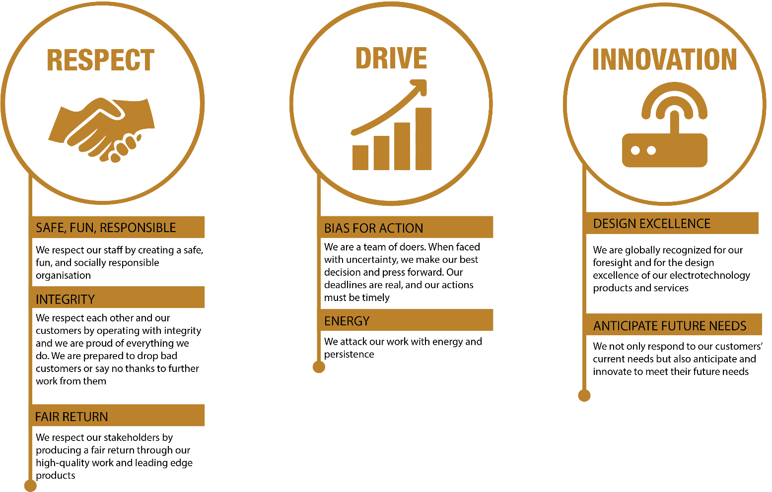

|  |  |  |  |  |
| --- | --- | --- | --- | --- |
| **REVIEWED BY:** |  |  | **DATE:** |  |
|  |  |  |  |  |
| **Last updated by:** | People and Culture |  | **Date/Time:** | May 2025 |