Job description
Title | Procurement Manager (Contract)
Location | Whangarei or Auckland
Start Date | June 2026
Reports To | Executive General Manager – Finance & Commercial
Reviewed By | Vidura Galpoththage | Date: | May 2026
Last Updated By | People & Culture | Date: | May 2026
Purpose:
The Procurement Manager is accountable for defining the future-state operating model, implementing fit-for-purpose governance and systems, and transitioning day-to-day project procurement delivery to an internal Procurement Lead, while retaining strategic and risk oversight. The role is explicitly outcome-focused, with success defined by what is designed, embedded, and handed over at the conclusion of the contract.



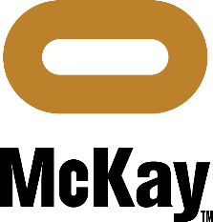

Role Summary
McKay is proud to stand as Aotearoa, New Zealand’s largest privately owned electrotechnology provider, offering innovative electrical engineering and construction services nationwide.
This role is a 9-month fixed-term contract established to design, stand up, and embed McKay’s procurement function as a sustainable, enterprise capability.
While this role sits at Procurement Manager level, the scope, accountabilities, and measures of success set out below override the standard BAU scope normally associated with a permanent Procurement Manager position for the duration of the contract. The primary mandate is procurement function establishment, uplift, and transition, rather than long-term operational ownership.
The Procurement Manager will have a Procurement Lead reporting to them, responsible primarily for project-related procurement execution, while the Procurement Manager focuses on strategy, governance, operating model design, capability uplift, and executive engagement.
The role operates as the functional authority for procurement across the McKay Group, partnering with executive, commercial, operational, and project leadership to ensure procurement is a strategic enabler of performance rather than a transactional service
The Procurement Manager is accountable for leading a mature, scalable procurement function that supports:
- Major projects and regional delivery
- Business-as-usual operations
- Overhead and indirect spend (corporate, IT, fleet, property, professional services, utilities, and consumables)
The role establishes clear procurement governance, develops strategic supplier and category management approaches, and ensures consistent execution across the full lifecycle—from sourcing and contracting through to performance management and continuous improvement.

Key Responsibilities for Contract

Procurement Function Design & Establishment
  - Design and implement McKay’s enterprise procurement operating model, spanning:
  - Projects
  - Core operations
  - Operational and corporate overhead spend
  - Define and document clear roles, responsibilities, decision rights, and interfaces between Procurement, Commercial, Projects, Operations, Finance, HSEQ, IT, and People & Culture.
  - Establish pragmatic procurement governance frameworks, including:
  - Policies, standards, and procedures
  - Delegations of authority
  - Approval, escalation, and assurance pathways
  - Develop and execute a phased procurement establishment roadmap, clearly linking implementation activities to handover milestones

Governance, Framework & Tooling
  - Design, implement, and embed standardised procurement frameworks, templates, and playbooks, including:
  - Strategic sourcing and tendering approaches
  - Contracting and sub-agreement templates (in collaboration with the Commercial function)
  - Supplier onboarding, compliance, and assurance processes
  - Performance management and continuous improvement mechanisms
  - Define fit-for-purpose governance for procurement systems and tools, including:
  - Materials tracking
  - Tools and equipment tracking
  - Supplier and contract registers
  - Ensure all frameworks, tools, and processes are fully documented, repeatable, and ready for business-as-usual ownership at contract end.

Strategic & High-Risk Procurement Oversight
  - Retain direct accountability for strategic, high-value, or high-risk procurement activities during the contract period.
  - Provide senior-level oversight and commercial assurance across:
  - Major project procurement strategies
  - Critical subcontractor and supplier negotiations
  - Complex, non-standard, or high-risk contractual arrangements
  - Act as the escalation point for material procurement-related risk, supplier failure, or dispute resolution.

Operational & Overhead Procurement Set-Up
  - Establish structured, enterprise-wide procurement approaches for non-project and overhead expenditure, including:
  - Professional and corporate services
  - IT systems, software, and telecommunications
  - Fleet, plant, facilities, and property-related spend
  - Utilities, consumables, and general overheads
  - Develop preferred supplier panels, master agreements, and pricing frameworks to:
  - Reduce supplier fragmentation
  - Improve cost transparency and control
  - Enable consistent service levels across the organisation
  - Partner with functional leaders to embed clear engagement models for operational and corporate procurement.

Supplier Strategy & Performance Frameworks
  - Design supplier segmentation and relationship models appropriate to McKay’s scale, maturity, and delivery profile.
  - Establish supplier performance management frameworks covering:
  - Strategic suppliers
  - Project-critical suppliers and subcontractors
  - Operational and overhead suppliers
  - Embed safety, quality, compliance, and performance expectations into procurement and supplier governance processes.

Leadership, Capability Uplift & Transition
  - Provide direct leadership, coaching, and capability uplift to the Procurement Lead, with clear accountability for:
  - Project-related procurement execution
  - Application of newly established procurement frameworks, tools, and governance
  - Progressively transition day-to-day project procurement activities to the Procurement Lead as capability matures.
  - Uplift procurement capability across project, operational, and functional teams through structured guidance and practical tools.

Handover, Sustainability & Exit Readiness
  - Ensure all procurement processes, frameworks, templates, contracts, supplier arrangements, and governance artefacts are fully documented and centrally accessible.
  - Deliver a structured end-of-contract handover, including:
  - The future-state procurement operating model
  - Open risks, issues, and improvement opportunities
  - Clear recommendations for ongoing resourcing, governance, and capability development

Qualifications & Knowledge

Qualifications
  - Tertiary qualification in Procurement, Supply Chain Management, Commerce, Business, Engineering, Construction Management, or a related discipline, or equivalent practical experience.
  - Professional procurement accreditation (e.g. CIPS, MCIPS, or equivalent) is desirable.
  - Contract management or commercial management qualifications are advantageous.

Essential Experience
  - Extensive experience in a senior procurement, commercial, or supply chain leadership role within construction, engineering, infrastructure, or complex service environments.
  - Proven track record of leading enterprise procurement functions across projects and indirect spend.
  - Demonstrated success in developing procurement strategies, governance frameworks, and supplier management models.
  - Strong experience with contract formation, negotiation, and lifecycle management.
  - Proven ability to operate at a senior level, influencing outcomes across multiple stakeholders.

Technical & Professional Capability
Strong working knowledge of:
  - Procurement governance and best practice
  - Contract and commercial risk management
  - Strategic sourcing and category management
  - Supplier performance and relationship management
  - High commercial acumen, balancing cost, quality, programme, and risk.

Leadership & Behavioural Competencies
  - Strategic thinker with a pragmatic, delivery focused mindset
  - Confident, credible senior leader with strong influencing capability
  - Structured, analytical, and outcomes driven
  - Strong alignment with safety, integrity, and ethical procurement practices

Role Profile

The Procurement Manager is accountable for:
  - Enterprise-wide procurement governance and strategy
  - Project, operational, and overhead procurement performance
  - Supplier and contract risk management
  - Cost efficiency, value optimisation, and commercial assurance
  - Consistent and compliant procurement execution across the McKay Group

Key Internal Interfaces
  - Executive Leadership Team – Strategic alignment, risk, and value delivery
  - Commercial Function – Contract strategy, risk allocation, execution assurance
  - Preconstruction / BD / Estimating – Supply chain strategy and pricing
  - Operations & Project Delivery – Procurement execution and performance
  - Finance – Cost control, spend visibility, governance
  - IT, P&C, HSEQ – Operational and overhead supplier alignment

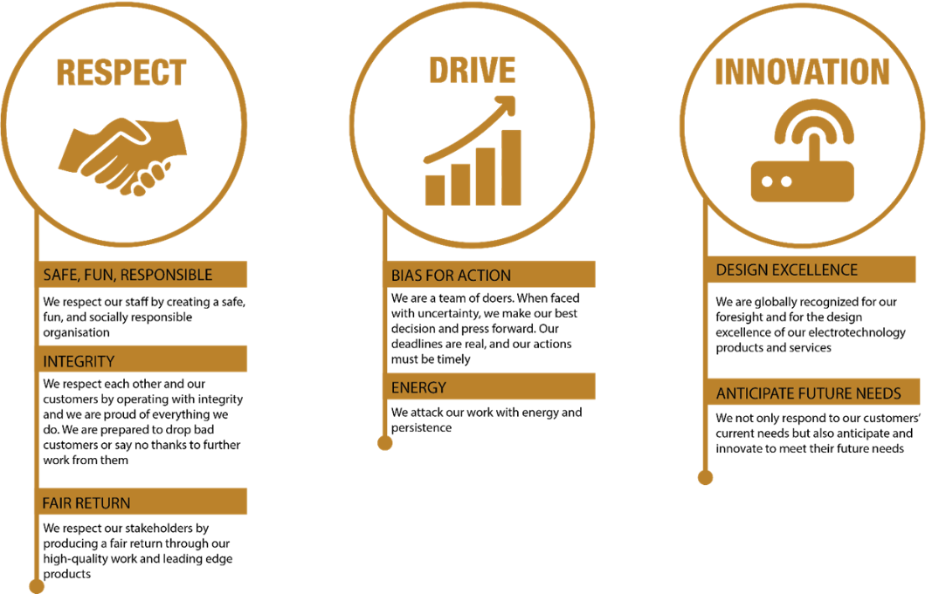
McKay Guiding Values

Appendices

1) 0–3 / 3–6 / 6–9 Month Delivery Map
This delivery map provides a clear, time-phased view of outcomes expected across the 9-month contract term and is intended to support contractor engagement, approval, and performance oversight.

Months 0–3 | Diagnose, Design & Mobilise
Primary Focus: Establish foundations, assess current state, and design the future state.

Key Outcomes
  - Current-state assessment of procurement practices across projects, operations, and overhead spend
  - Clear definition of the future-state enterprise procurement operating model
  - Executive alignment on procurement vision, scope, and governance

Key Deliverables
  - Procurement operating model design (roles, decision rights, interfaces)
  - Draft procurement policies, standards, and delegations of authority
  - Procurement establishment roadmap with phased milestones
  - Initial supplier spend analysis and risk profile
  - Procurement Lead role clarity, priorities, and capability development plan

Months 3–6 | Build, Implement & Embed
Primary Focus: Implement core frameworks, transition execution, and embed governance.

Key Outcomes
  - Procurement frameworks operating across major projects
  - Governance and approval pathways actively in use
  - Reduced fragmentation and improved control across priority spend categories

Key Deliverables
  - Implemented sourcing, tendering, and contracting frameworks
  - Preferred supplier panels and master agreements for targeted categories
  - Supplier onboarding, compliance, and performance management processes live
  - Procurement systems and registers established (materials, tools, suppliers, contracts)
  - Progressive transition of project procurement execution to the Procurement Lead

Months 6–9 | Stabilise, Transition & Handover

Primary Focus: Achieve sustainability, reduce dependency, and complete handover.
Key Outcomes
  - Procurement function operating effectively without day-to-day Manager involvement
  - Procurement Lead independently supporting project delivery
  - Executive confidence in procurement governance and assurance
Key Deliverables
  - Fully documented procurement frameworks, templates, and playbooks
  - Finalised supplier strategies and performance baselines
  - Defined BAU ownership model and governance cadence
  - End-of-contract handover pack, including open risks and improvement opportunities
  - Recommendations for future procurement maturity uplift

2) Contract Scorecard – Procurement Function Set-Up
This scorecard translates procurement outcomes into Finance-led performance measures aligned to executive reporting and review. It is designed for use in ELT and Finance forums to assess progress and value delivery during the contract term.

Finance Dimension | KPI Focus | How It Is Measured | Evidence / Artefacts | Review Cadence
EBIT & Value | Procurement-driven EBIT contribution | Quantified cost savings, cost avoidance, and margin protection attributable to sourcing and supplier strategies | Sourcing business cases, supplier agreements, Finance validations | Monthly / Quarterly
Margin Protection | Project margin predictability | Variance between tendered supplier pricing and delivered cost outcomes | Tender vs actual analysis, post-award reviews | Project gate / Monthly
Cash & Working Capital | Cashflow impact of procurement decisions | Improvement in payment terms, milestone structures, and reduced dispute-related delays | Contract terms, cashflow forecasts, dispute logs | Monthly
Risk Exposure | Supplier and commercial risk reduction | Reduction in number and severity of high-risk suppliers and contracts | Supplier risk register, contract reviews | Quarterly
Governance & Assurance | Procurement compliance and assurance | Percentage of spend flowing through approved procurement frameworks | Spend analysis, audit outcomes | Quarterly
Capability & Sustainability | BAU readiness post-contract | Procurement Lead operating independently; frameworks embedded | Handover pack, operating model sign-off | End-of-contract

