JOB TITLE: | Finance Business Partner
Location: | Auckland or Whangarei |  | Date: | Oct 2025
Reports to: | Head of Finance
Purpose: | To support the efficient functioning of the finance functions within the organisation.
ROLE SUMMARY:
Having started providing electrotechnology services in 1936, McKay is a historic New Zealand electrical company with a depth of experience in providing end to end electrical solutions for a wide range of industries and sectors. McKay is the parent brand and has acquired and started a range of companies under the McKay Group name in order to serve all electrical needs.
As a Finance Business Partner at McKay Ltd., you will play a crucial role to provide finance business partnering expertise to the operational business units within the McKay Group of companies. This role is on site in either Auckland or Whangarei. The role will be expected to travel to McKay Group locations from time to time for the purpose of developing close working relationships with the operational staff and building their financial knowledge.

RESPONSIBILITIES:

- Financial Support:
  - Provide commercial finance support, analysis and advice to the operational business unit managers and contract administrators as required
  - Manage construction bond requirements
  - Assist the operational managers with preparing and analysing:
    - monthly financial results,
    - forecasts
    - annual budgets
  - Drive successful operational business unit cash collection to targets
  - Display financial and commercial acumen
  - Build and maintain effective networks and relationships with key internal and external stakeholders
  - Be a great team member and work collaboratively with colleagues
  - Work behaviours that reflect the company values and vision
- Communication:
  - Communicate effectively with team members and external stakeholders.
  - Respond to financial inquiries.

QUALIFICATIONS & KNOWLEDGE:
Required:
- A degree or diploma in business management, commerce and/or accounting
- Strong excel skills
- Experience in a commercial organisation in either the finance or commercial function
- Knowledge of Oracle NetSuite, EP, SAP or similar ERP
- Accuracy and attention to detail
- Ability to extract and analyse data
- Able to effectively meet deadlines
- Enthusiasm and drive
- A strong understanding of health and safety in a construction business environment
- Builds effective professional working relationships across the business with internal customers
Of Advantage:
- Experience with the electrical and/or construction industries
- Knowledge of job management systems
ROLE PROFILE:

As a Finance Business Partner at McKay Ltd., you must hold the following capabilities;
- Proficiency in accounting software and Microsoft Office Suite.
- Strong organisational and time-management skills.
- Excellent attention to detail and accuracy.
- Effective communication skills, both written and verbal.
- Ability to work independently and as part of a team.
- Trustworthy and able to handle sensitive financial information
- Proactive and able to take initiative.
- Problem-solving skills and ability to multitask.
- Adaptability and flexibility in a dynamic work environment.
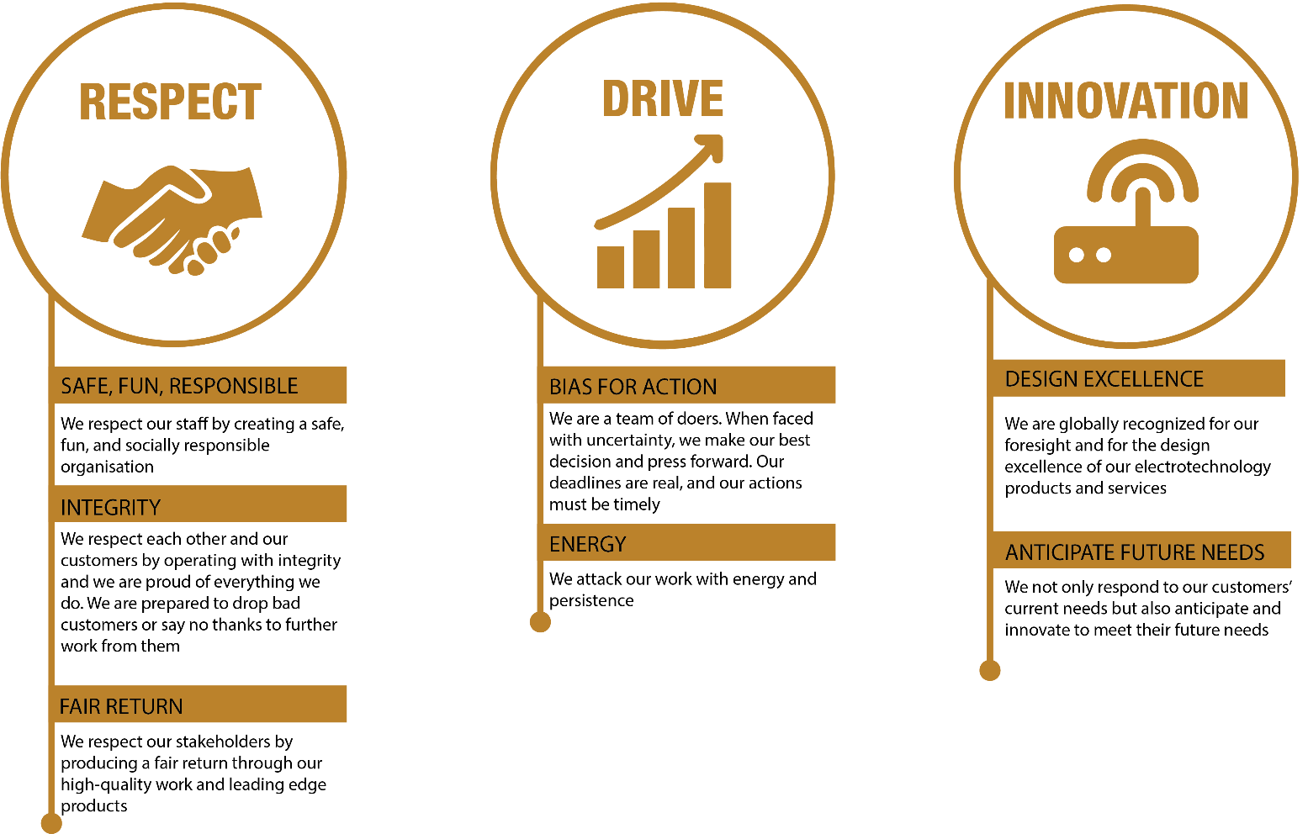
McKay GUIDING VALUES:

REVIEWED BY: | W Coutts |  | DATE: | Oct 2025
Last updated by: | People and Culture |  | Date/Time: | July 2025

