Job description
Title | Marketing Communications Specialist (12-month fixed term contract)
Location | Auckland or Whangarei
Start Date | 2 June 2026
Reports To | Louise Burgess, EGM Business Development & Marketing
Reviewed By | Louise Burgess | Date: | April 2026
Purpose:
As a Marketing and Communications Specialist, you will support the development and execution of integrated marketing and communications strategies that promote the McKay brand, strengthen engagement with target audiences, and drive business objectives. You will create compelling content, manage multi-channel campaigns, and ensure consistent messaging across all media.
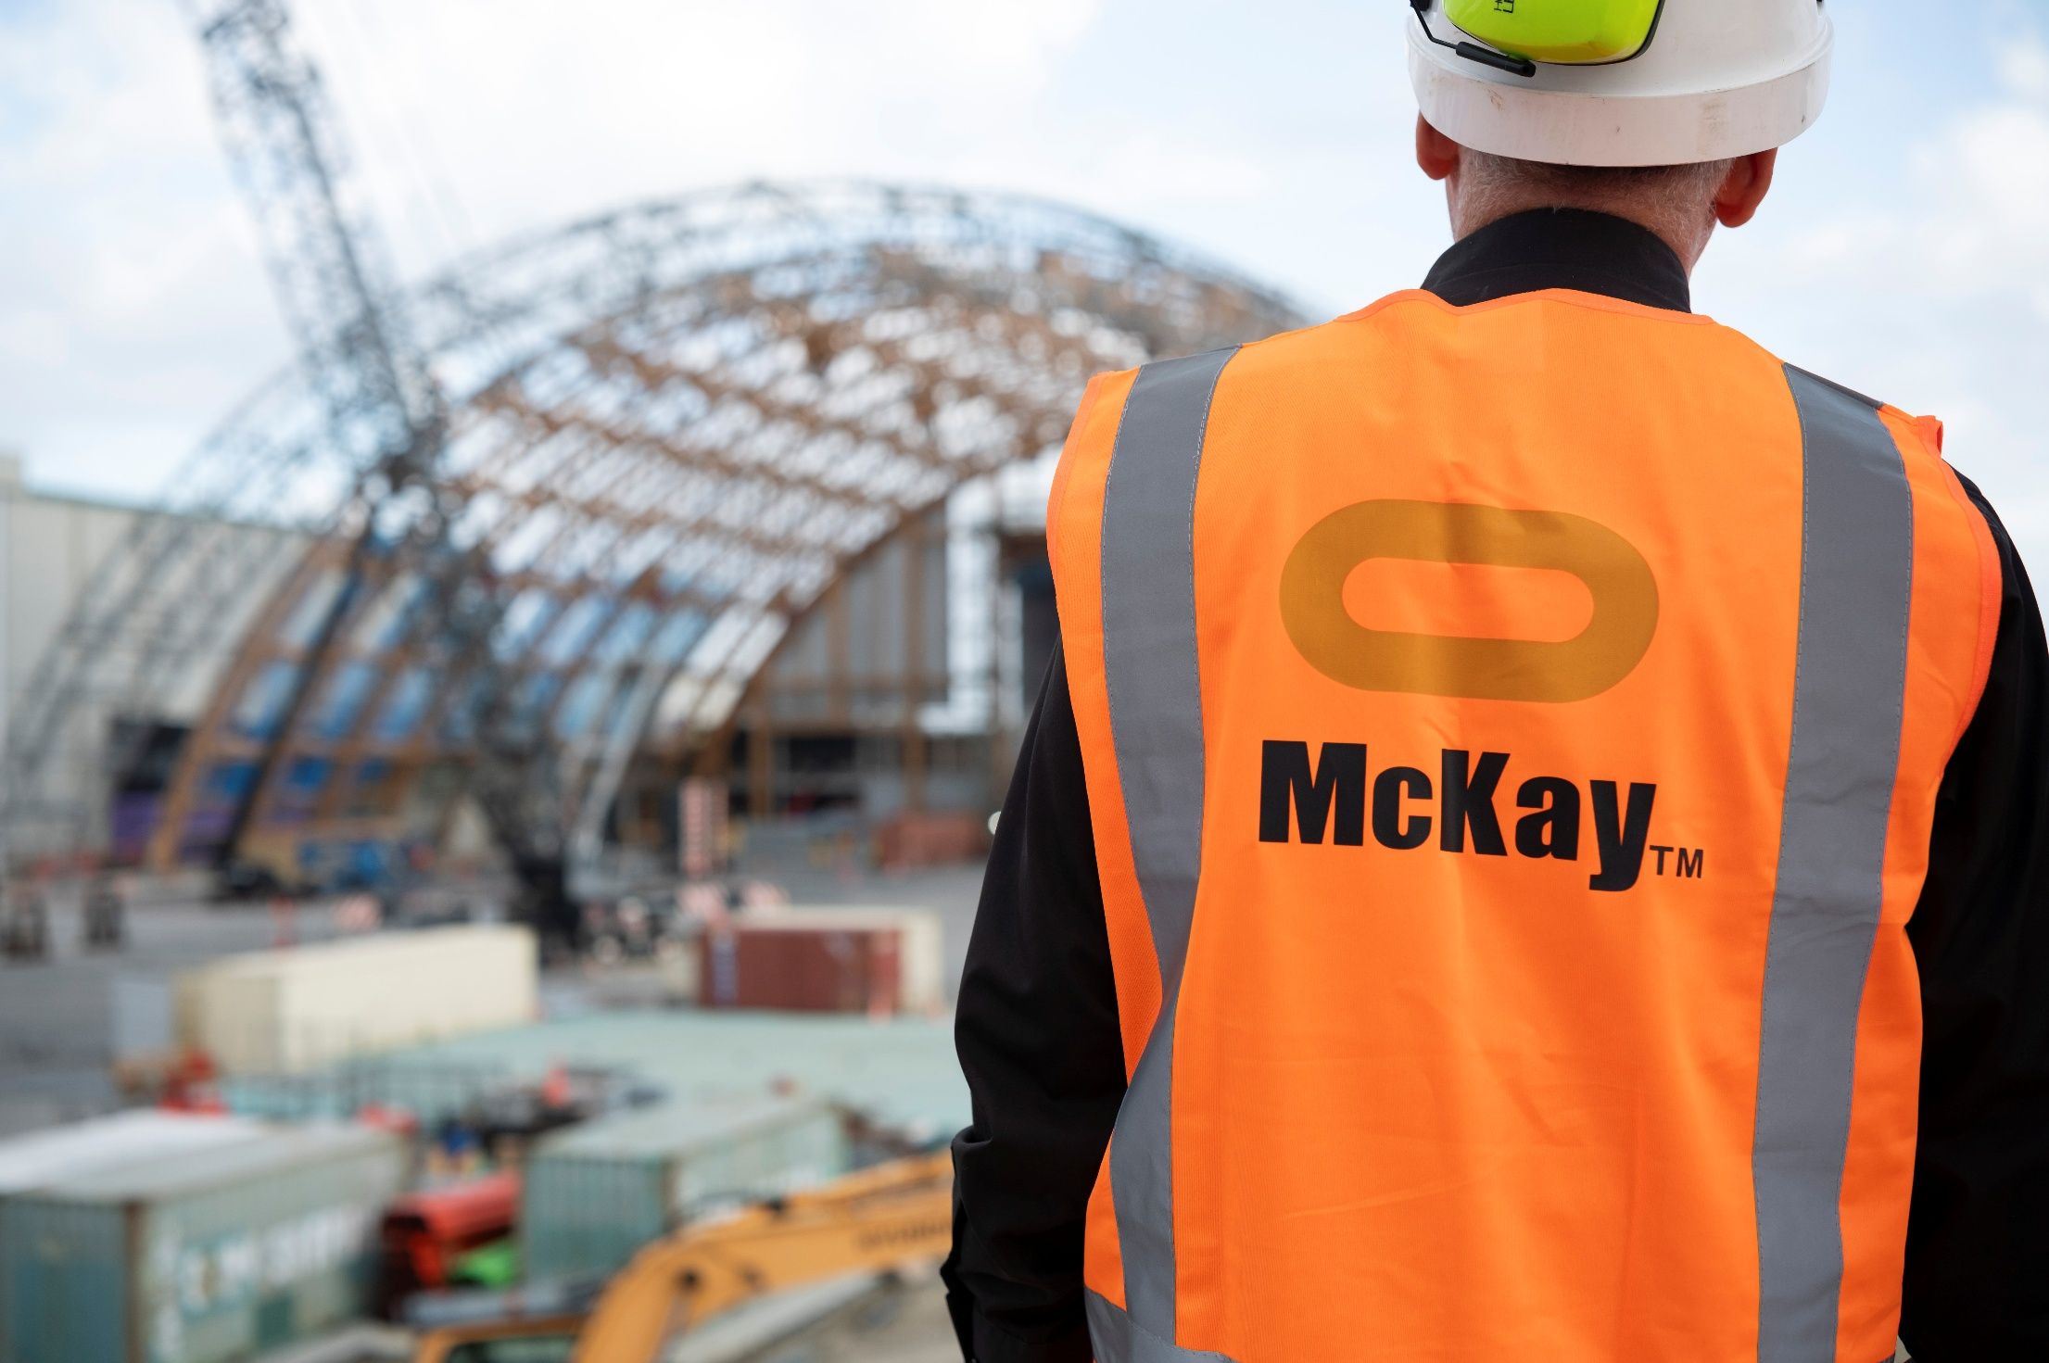



Role Summary
McKay is proud to stand as Aotearoa, New Zealand’s largest privately owned electrotechnology provider, offering innovative electrical engineering and construction services nationwide.
Having started providing electrotechnology services in 1936, McKay is a historic New Zealand electrical company with a depth of experience in providing end to end electrical solutions for a wide range of industries and sectors. McKay is the parent brand and has acquired and started a range of companies under the McKay Group name to serve all electrical needs.
As the Marketing and Communications Specialist at McKay Limited, you will support the delivery of engaging, on-brand communications across digital and traditional channels. The role focuses on creating compelling content, supporting integrated campaigns, and ensuring consistent messaging that connects with key audiences and supports business objectives.

Responsibilities

Marketing Strategy & Brand Development
- Develop channel-level micro-marketing strategies and campaign plans that align with McKay’s overarching marketing strategy.
- Contribute to the ongoing development and ownership of the McKay brand, ensuring consistency across all marketing materials and communications.
- Identify opportunities to strengthen McKay’s market positioning across key sectors and geographic markets.
- Stay informed on industry trends and market developments to inform marketing activity and messaging.

Campaign & Project Management
- Lead marketing projects from concept through to execution and performance review.
- Plan and deliver multi-channel marketing campaigns across digital and traditional platforms.
- Coordinate internal stakeholders across McKay branches, sectors, and leadership teams to deliver marketing initiatives.
- Manage timelines, deliverables, and outcomes across multiple concurrent projects.

Budget Management
- Make budget recommendations for projects, campaigns, or events, and then manage spend and reconciliation upon approval from the EGM Business Development & Marketing.

Content & Communications
- Develop and oversee the creation of marketing content, including case studies, website content, articles, press releases, newsletters, and campaign materials.
- Regularly produce blog and thought leadership content for the McKay website.
- Support marketing communications for major bids, tenders, and account-based marketing initiatives.
- Support internal communications initiatives.
- Ensure all communications reflect McKay’s brand voice and positioning.

Digital Marketing & Channels
- Develop, schedule, and maintain social media content across McKay channels.
- Support website development and content management through WordPress.
- Contribute to the development and optimisation of digital marketing activity, including SEO, analytics, CRM, and marketing automation.

Events & Industry Engagement
- Plan and manage McKay’s participation in trade shows, conferences, and industry events.
- Coordinate marketing collateral and promotional activity associated with events and industry engagement.

Agency & Supplier Management
- Manage relationships with external marketing suppliers and agencies, including designers, digital specialists, photographers, and marketing providers.
- Develop clear scopes of work and oversee delivery to ensure quality and alignment with Marketing and BD Team objectives.

Marketing Systems & Reporting
- Support the ongoing development and utilisation of McKay’s CRM (HubSpot) and associated marketing systems.
- Track marketing performance and provide regular reporting and insights to the EGM Business Development & Marketing.
- Identify opportunities to improve marketing processes, tools, and campaign performance.

Qualifications & Knowledge
- Bachelor’s degree in marketing, business, or a related field.
- Proven experience in digital marketing, preferably in the electrical or construction sectors.
- 5-10 years’ marketing and communications experience.

Role Profile
As the Marketing and Communications Specialist at McKay Electrical Ltd., you will have the following capabilities;
- Strong knowledge of SEO, SEM, social media, and email marketing best practices.
- Excellent written and verbal communication skills.
- Proficiency in digital marketing tools and analytics platforms.
- Creative thinker with the ability to develop and execute innovative campaigns.
- Strong analytical and problem-solving skills.

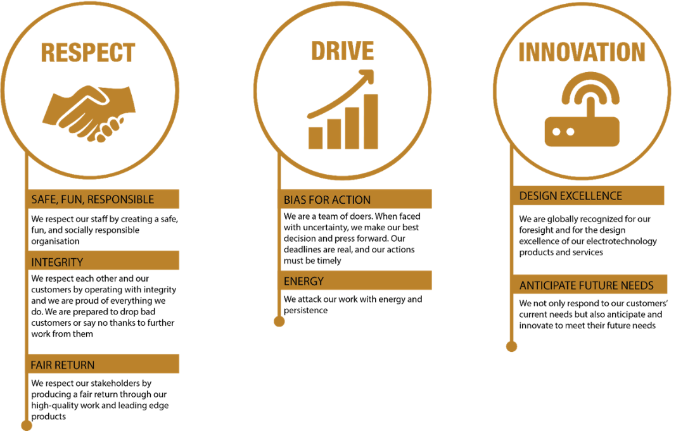
McKay Guiding Values

