JOB TITLE: | Electrician
Location: |  |  | Date:
Reports to:
Purpose: | To be responsible for the installation, maintenance, and repair of electrical systems and equipment.
ROLE SUMMARY:
Having started providing electrotechnology services in 1936, McKay is a historic New Zealand electrical company with a depth of experience in providing end to end electrical solutions for a wide range of industries and sectors. McKay is the parent brand and has acquired and started a range of companies under the McKay Group name in order to serve all electrical needs.
As an Electrician at McKay Electrical Ltd., you are a skilled tradesperson responsible for the installation, maintenance, and repair of electrical systems and equipment. You will work in a variety of settings, from residential homes and commercial buildings to industrial facilities. They ensure that electrical systems are safe, reliable, and in compliance with relevant codes and regulations.

RESPONSIBILITIES:

- Electrical Installation:
  - Install wiring, electrical panels, outlets, and fixtures in new construction and renovation projects.
  - Determine the appropriate placement and layout of electrical components.
  - Connect wiring to transformers, circuit breakers, or other components.
- Maintenance and Repair:
  - Troubleshoot electrical problems to identify faults and issues.
  - Repair or replace damaged or outdated electrical components, such as switches, outlets, and fixtures.
  - Perform routine maintenance to prevent electrical system failures.
- Compliance and Safety:
  - Ensure all electrical work adheres to local, state, and national electrical codes.
  - Inspect electrical systems to identify potential safety hazards and rectify them.
  - Follow safety protocols and guidelines to minimise electrical risks.
- Reading Blueprints and Technical Documents:
  - Interpret blueprints, technical diagrams, and schematics to plan and execute electrical installations.
  - Review specifications to ensure compliance with project requirements.
- Equipment and Tool Management:
  - Maintain and repair tools and equipment used in electrical work.
  - Keep tools and equipment in good working condition, following safety guidelines.
- Customer Communication:
  - Communicate with customers to understand their electrical needs and provide cost estimates for projects.
  - Explain the work performed and educate customers about electrical safety.
- Up-to-Date Knowledge:
  - Stay informed about advancements in electrical technology, regulations, and safety standards.
  - Participate in ongoing training and professional development to enhance skills.
- Documentation:
  - Create and maintain records of electrical work performed, including wiring diagrams, maintenance logs, and repair reports.
  - Submit necessary documentation for permits and inspections.

QUALIFICATIONS & KNOWLEDGE:

- Completion of an electrical apprenticeship program or relevant vocational training.
- Appropriate national electrician's license

ROLE PROFILE:

As an Electrician at McKay Electrical Ltd., you must hold the following capabilities;
- Strong knowledge of electrical codes and regulations.
- Proficiency in reading blueprints and technical diagrams.
- Excellent problem-solving and troubleshooting skills.
- Physical stamina and the ability to work in various environments, including confined spaces.
- Strong attention to detail and safety-conscious.
- Good communication and customer service skills.
- Basic computer skills for recordkeeping and communication.

McKay GUIDING VALUES:
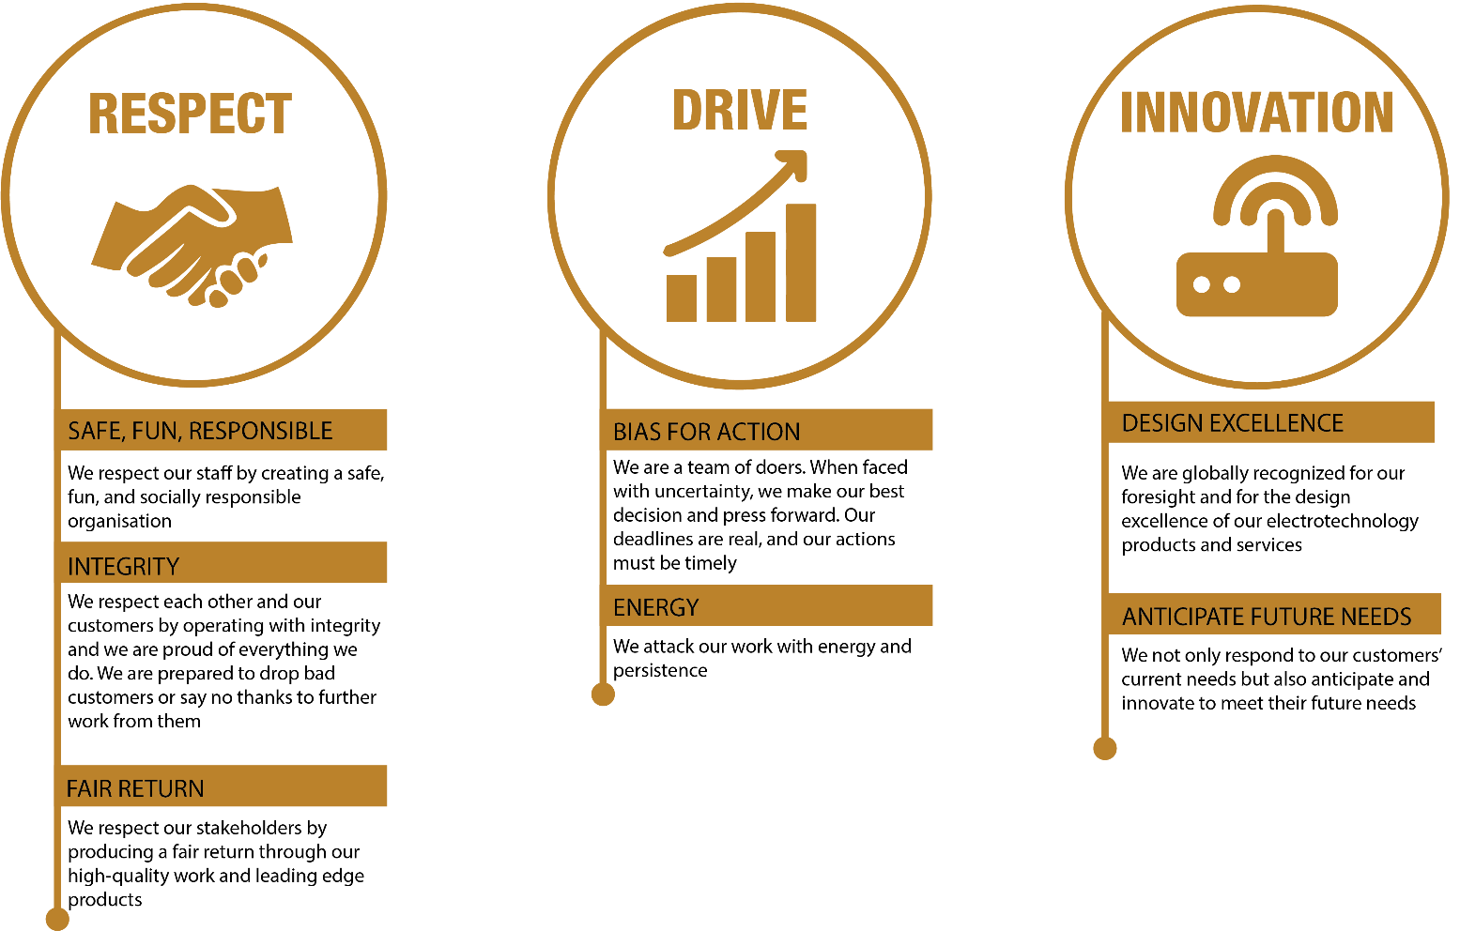

REVIEWED BY: |  |  | DATE:
Last updated by: | People and Culture |  | Date/Time: | Nov 23

