Job description
Title | Operations Manager, Waikato and Western Regions
Location | Hamilton, Waikato and Western Region
Start Date | November, 2025
Reports To | Regional Manager Waikato and Western Regions
Reviewed By | Stuart Archer | Date: | November, 2025
Last Updated By | People & Culture | Date: | November, 2025
Purpose:
To provide strong operational leadership and structure across the Waikato and Western Regions




Role Summary
McKay is proud to stand as Aotearoa, New Zealand’s largest privately owned electrotechnology provider, offering innovative electrical engineering and construction services nationwide.
The Operations Manager provides strong operational leadership across the Waikato and Western Regions. The role ensures effective planning, labour coordination, client communication, supervisory support, and consistent delivery across all work streams. It brings structure, clarity, and leadership presence to daily operations, enabling teams to perform at a high level.
This position stabilises operations, strengthens leadership capability across Project Managers and supervisors, and supports the Regional Manager by taking ownership of day-to-day operational coordination. It also builds long-term leadership depth and succession capability within the region.

Responsibilities

Leadership and Team Direction
  - Provide strong operational leadership across delivery teams in the Waikato and Western Regions
  - Set clear expectations, communication routines, and behavioural standards for Project Managers, supervisors, and support staff
  - Enable teams to succeed through structure, planning discipline, decision-making support, and visible leadership
  - Coach and develop leaders to lift capability, confidence, and ownership
  - Strengthen a culture of accountability, collaboration, and continuous improvement

Operational Management
  - Oversee day-to-day operational performance across all branch activities, ensuring work is delivered to required standards, timeframes, and commercial expectations
  - Ensure planning, scheduling, and resource allocation processes are consistent, efficient, and predictable across all work streams
  - Maintain strong operational standards including documentation quality, job readiness, workflow discipline, and delivery consistency
  - Identify operational issues early across any part of the branch and drive timely resolution through the appropriate leaders

Quality & Health & Safety:
  - Lead visible engagement in safety, quality, and compliance, supporting effective HSEQ implementation
  - Promote high standards of operational discipline, documentation, and site practice
  - Monitor operational risks and ensure mitigation actions are embedded across teams
  - Support continuous improvement of quality and H&S processes in partnership with HSEQ

Labour Planning & Resource Coordination:
  - Strategically lead labour planning across all work streams
  - Improve labour utilisation by embedding structured planning processes
  - Coordinate resources between teams to optimise workflow and minimise reactive changes
  - Maintain clear communication on labour priorities, capacity, and constraints

Client & Stakeholder Coordination:
  - Act as a senior operational contact to ensure clear and timely communication
  - Support Project Managers and supervisors in resolving operational issues
  - Reinforce reliable delivery and professional conduct across all engagements

Commercial & Estimating Alignment:
  - Ensure operational input is incorporated into planning, estimating, and commercial decisions
  - Support accurate scoping, delivery methodologies, and resource planning
  - Maintain alignment between operational capability and commercial commitments

Operational Improvement & Future Readiness
  - Implement consistent operational routines, planning frameworks, and communication structures that strengthen delivery performance
  - Identify operational bottlenecks and drive practical improvements across workflows, documentation, and coordination
  - Assess operational capability and structure required to support future service lines or regional growth
  - Provide input into long-term workforce, capability, and supervision requirements
  - Support the operational setup and integration of new service offerings as the region expands

Qualifications & Knowledge
  - Bachelor’s degree in Electrical Engineering, Business Administration, or a related field
  - Proven experience in a managerial role within the electrical industry
  - Strong operational understanding of electrical contracting environments
  - Good planning, coordination, and organisational capability
  - Effective communication and problem-solving skills

Role Profile
As the Operations Manager at McKay Electrical Ltd., you must hold the following capabilities;
  - Confidence in managing workflow and coordinating multiple work streams
  - Ability to identify operational issues early and drive practical solutions
  - Clear, professional communication and strong interpersonal skills
  - Ability to interpret operational information to support effective decision-making
  - Strong attention to detail and commitment to consistent delivery standards

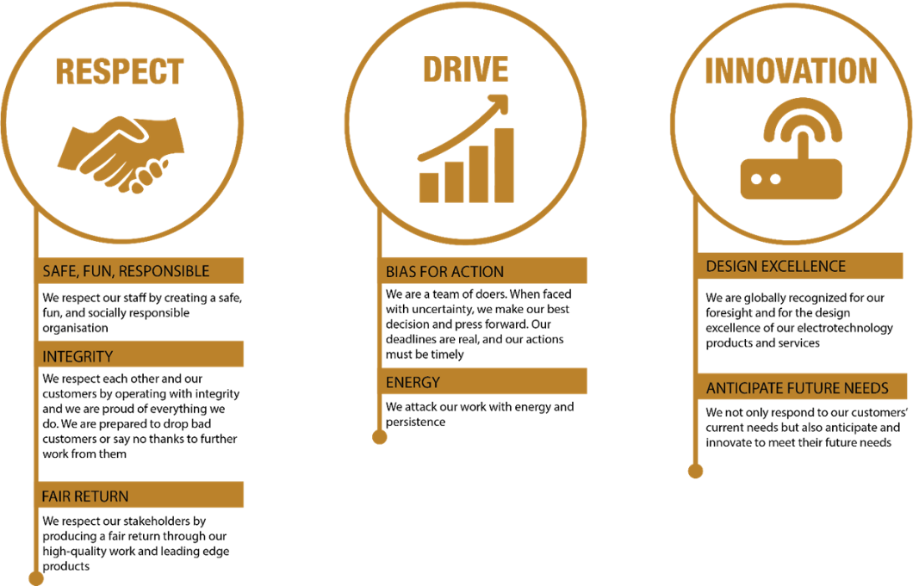
McKay Guiding Values

