JOB TITLE: | Leading Hand Line Mechanic – Northland
Location: | Whangārei |  | Date: | September 2025
Reports to: | Northland – Distribution Manager
Purpose: | Play a crucial role in leading, overseeing and coordinating the activities of a team of Line Mechanics and/ or subcontractors.
ROLE SUMMARY:
Having started providing electrotechnology services in 1936, McKay is a historic New Zealand electrical company with a depth of experience in providing end to end electrical solutions for a wide range of industries and sectors. McKay is the parent brand and has acquired and started a range of companies under the McKay Group name in order to serve all electrical needs.
Our Northland Distribution division is a trusted partner in maintaining and enhancing the region’s electrical networks. At McKay, we value safety, teamwork, and leadership to deliver quality outcomes for our clients and communities.
As the Leading Hand – Line Mechanic at McKay Ltd., you will play a crucial role in showcasing our technical capabilities and commitment to strong customer relationships. With ongoing growth in the distribution, renewables, and infrastructure sectors, this position focuses on delivering responsive and customer-oriented solutions.

RESPONSIBILITIES:

- Team Leadership:
  - Lead, motivate, and supervise a team of Line Mechanics and/ or subcontractors.
  - Allocate tasks and responsibilities to team members based on their skills and expertise.
  - Conduct regular toolbox meetings to communicate project objectives, expectations, and updates.

- Technical Expertise:
  - Demonstrate a high level of technical proficiency in electrical systems and equipment.
  - Provide hands-on support and guidance to team members during complex installations, repairs, and maintenance activities.
  - Stay updated on industry trends, technological advancements, and safety regulations.

- Project Management:
  - Oversee the planning, execution, and completion of electrical projects.
  - Collaborate with project managers to ensure timelines and budgets are met.
  - Monitor project progress and address any issues that may arise during the course of the project.
  - Maintain accurate records of work performed, including inspections, repairs, and equipment replacements.
  - Complete and submit work orders, reports, and documentation as required.

- Quality Assurance:
  - Ensure that all work meets quality standards and adheres to relevant codes and regulations.
  - Conduct inspections and quality checks on completed work.
  - Implement corrective actions as needed to address quality issues.

- Safety Compliance:
  - Enforce and promote a strong safety culture within the team.
  - Conduct regular safety briefings and training sessions.
  - Investigate and report any accidents or safety incidents.

- Communication:
  - Effectively communicate with team members, management, and clients.
  - Provide regular updates on project status, challenges, and achievements.
  - Foster open communication within the team to encourage feedback and collaboration.

QUALIFICATIONS & KNOWLEDGE:

- Registered Line Mechanic (Distribution) with a current practising license.
- Competency in Live Line, HV switching, Jointing, Streetlights, and distribution network operations.
- Minimum 5 years’ experience in distribution line work.
- Demonstrated leadership or team coordination experience (formal or informal).
- Full New Zealand driver’s license (Class 2)
- EWRB registration and current first aid certificate.

ROLE PROFILE:

As a Leading Hand – Line Mechanic at McKay Ltd., you must hold the following capabilities;
- Knowledge of electrical systems, safety procedures, and industry regulations.
- Ability to climb utility poles, work at heights, and perform physically demanding tasks.
- Experience operating and maintaining power line equipment and tools.
- Strong problem-solving and troubleshooting skills.
- Excellent communication and teamwork skills.
- Willingness to work flexible hours, including evenings, weekends, and occasional pre-planned away work.

McKay GUIDING VALUES:

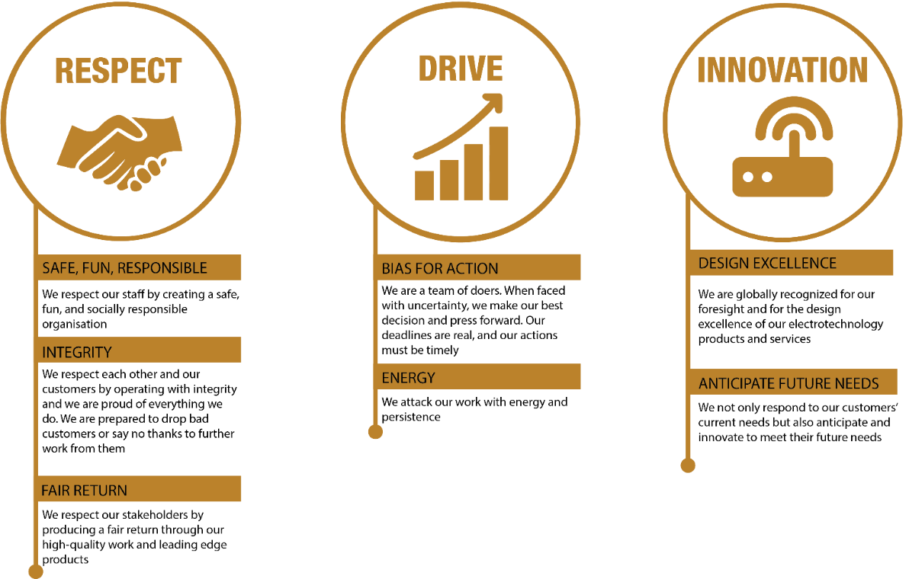

REVIEWED BY: | Joel Freeman |  | DATE: | Sept 2025
Last updated by: | People and Culture |  | Date/Time: | Sept 2025

