
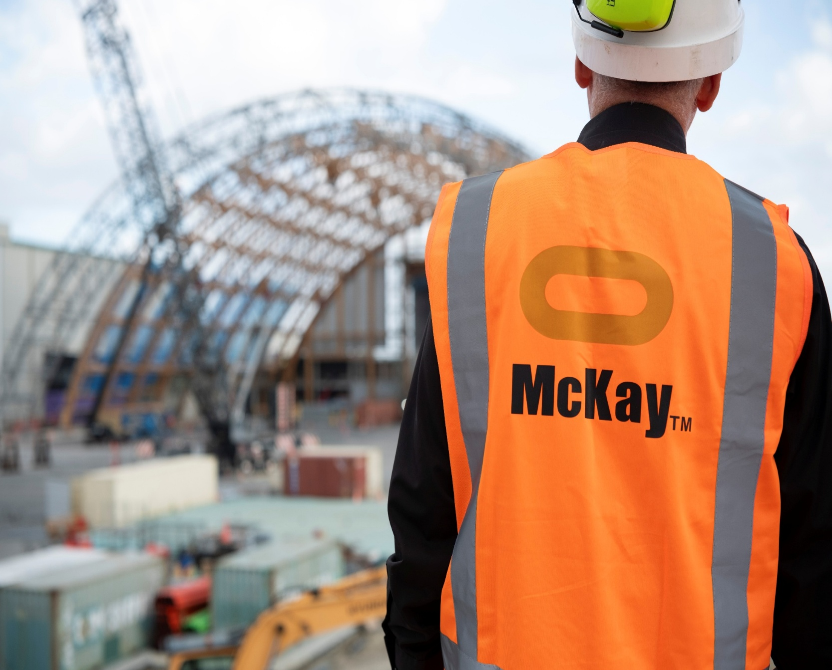
Quality Lead
Title | Quality Lead
Location | Flexible
Start Date | February, 2026
Reports To | HSEQ Manager
Reviewed By | Herby Barnes | Date: | Feb, 2026
Last Updated By | People & Culture | Date: | Feb, 2026
Purpose:
The Quality Lead is responsible for ensuring that all electrical installations and related activities across McKay projects are delivered to the highest standards of quality, safety, and compliance. This role oversees the implementation of McKay’s Quality Assurance Procedures, manages quality control processes, and ensures all legislative and company-specific requirements are met throughout the lifecycle of electrical works.

Role Summary
McKay is proud to stand as Aotearoa, New Zealand’s largest privately owned electrotechnology provider, offering innovative electrical engineering and construction services nationwide.
Having started providing electrotechnology services in 1936, McKay is a historic New Zealand electrical company with a depth of experience in providing end to end electrical solutions for a wide range of industries and sectors. McKay is the parent brand and has acquired and started a range of companies under the McKay Group name to serve all electrical needs.
The objective of the Quality Lead (Electrical Works) is to ensure that all electrical installations and related activities across McKay projects are delivered to the highest standards of quality, safety, and compliance. This role is responsible for developing, implementing, and maintaining quality assurance procedures, managing quality control processes, and ensuring all work meets legislative, regulatory, and company-specific requirements. The Quality Lead drives continuous improvement in quality delivery, minimises defects and rework, and ensures that McKay’s reputation for excellence is upheld in every project.

Responsibilities

Maintaining Quality and Assurance
- Develop, implement, and maintain company-wide and project-specific Quality Plans in accordance with McKay’s Quality Assurance Procedures Manual and ISO 9001 requirements.
- Ensure all electrical works comply with relevant New Zealand legislation, standards, and codes, including the Electricity Act, Health and Safety at Work Act, Electricity (Safety) Regulations, Building Code, AS/NZS standards, and contract-specific requirements.
- Oversee quality assurance and quality control processes, including planning, inspection, testing, verification, commissioning, and certification of all electrical installations.
- Conduct regular site audits, technical inspections, and quality reviews across projects to ensure delivery and workmanship meets best practice and contractual obligations.
- Intervene when project delivery practices are not as planned or in accordance with McKay’s quality procedures.
- Lead root cause analysis and corrective action processes when non-conformance, defects, or quality incidents occur.
- Ensure all staff understand their obligations with regard to McKay’s quality systems and understand why and where these systems need to be implemented.

Workflow, Technical Coordination and Project Support
- Monitor full workflow for electrical works, from planning through design, procurement, construction, inspection, testing, commissioning, and handover.
- Advise on and review shop drawings, technical submissions, work plans, inspection and test plans (ITPs), and commissioning documentation to ensure accuracy and compliance.
- Support project managers and supervisors in preparing quality documentation and ensuring testing, commissioning, and handover processes are delivered consistently.
- Provide technical guidance on methodologies, installation standards, and quality expectations to project teams, apprentices, and electricians.
- Ensure consistent application of QA/QC procedures across regions, divisions, and projects.

Compliance, Documentation and Reporting
- Ensure all required electrical certificates and records—including Certificates of Compliance, Electrical Safety Certificates, Producer Statements, test sheets, and commissioning records—are completed, compiled, and submitted accurately and on time.
- Oversee the preparation and quality of operation and maintenance manuals, as-built drawings, and project close-out documentation.
- Maintain quality performance metrics including audit outcomes, defects, non-conformance records, rework trends, and document control.
- Monitor, report, and escalate quality performance issues, ensuring nonconformances and defects are resolved promptly and effectively.
- Ensure documentation systems remain accurate, complete, and aligned with legislative, client, and audit requirements.

Leadership, Capability Development & Team Management
- Provide leadership and support to project teams to uplift quality performance and embed a culture of continuous improvement.
- Monitoring work packs to ensure competent personnel carry out prescribed electrical work in accordance with the Electricity (Safety) Regulations and the Electrical Workers Registration Board competency framework.
- Manage and review McKay’s technical competency register, ensuring team members hold appropriate qualifications, registrations, and supervision levels.
- Develop and deliver training on quality procedures, electrical standards, testing requirements, workmanship expectations, and technical compliance.
- Support apprentices, supervisors, project managers, and electricians in building technical capability and understanding of quality requirements.

Continuous Improvement & System Development
- Identify opportunities to enhance systems, processes, and field execution through data insights, audit findings, and trend analysis.
- Lead quality improvement initiatives across branches and divisions to reduce rework, improve documentation control, and increase first time-right performance.
- Contribute to the ongoing development of McKay’s Quality Management System, ensuring procedures reflect current best practice and operational needs.
- Champion a culture of quality, accountability, and technical excellence across all the organisations quality systems across all levels and roles in the business.

Stakeholder Engagement & External Coordination
- Liaise with contractors, consultants, suppliers, and regulatory authorities to ensure quality expectations are understood, met, and documented.
- Coordinate technical submissions, respond to client queries, and communicate changes affecting quality or compliance.
- Ensure factory acceptance tests (FATs), site acceptance tests (SATs), and other inspection and testing activities are being completed as required.
- Build strong relationships with clients to support confidence in McKay’s quality delivery and technical capability.

Required Skills, Experience & Qualifications

Qualifications
- Registered Electrician or Electrical Engineer with relevant New Zealand qualifications.
- Strong knowledge of NZ electrical legislation, compliance requirements, and AS/NZS standards.
- Lead Auditor (ISO 9001) or internal auditing certification preferred.
- Additional quality, continuous improvement, or project management certifications (e.g., Six Sigma, Lean, Prince2) are advantageous.

Experience
- Proven experience in quality management or technical quality leadership within electrical construction, infrastructure, industrial, or maintenance environments.
- Demonstrated experience implementing and managing quality systems, project quality plans, and audit programmes.
- Practical experience in inspection, testing, commissioning, and certification of electrical installations.
- Experience producing and reviewing ITPs, shop drawings, test plans, and compliance documentation.
- Strong background in managing documentation systems, registers, certifications, and technical submissions.
- Experience working closely with multidisciplinary teams, clients, consultants, inspectors, and regulatory bodies.

Skills
- In-depth technical knowledge of NZ electrical legislation framework prescribed electrical work requirements, and quality assurance processes.
- Excellent communication and leadership skills, with the ability to influence and coach at all organisational levels.
- Strong organisational and planning skills, with the ability to manage complex workflows and multiple priorities.
- Proficiency with quality management software, document control systems, and project management tools.
- Strong analytical and problem-solving skills, including root cause analysis and continuous improvement.
- Ability to build strong relationships with clients, regulators, and internal stakeholders.

McKay Guiding Values

