JOB TITLE: | Electrical Engineer
Location: | Whangarei |  | Date: | May 2024
Reports to: | Renewables Manager
Purpose: | To plan, execute, and successfully complete electrical projects.
ROLE SUMMARY:
Having started providing electrotechnology services in 1936, McKay is a historic New Zealand electrical company with a depth of experience in providing end to end electrical solutions for a wide range of industries and sectors. McKay is the parent brand and has acquired and started a range of companies under the McKay Group name in order to serve all electrical needs.
As an Electrical Engineer at McKay Ltd., you will play a crucial role in the planning, execution, and successful completion of electrical projects. This will require from you a combination of technical expertise, project management skills, and a deep understanding of electrical systems.

RESPONSIBILITIES:

- Project Planning and Design:
  - Conduct feasibility studies and assess project requirements.
  - Develop electrical system designs and plans.
  - Calculate load requirements and design electrical circuits and systems.
  - Select appropriate components, equipment, and materials.
- Regulatory Compliance:
  - Ensure that electrical designs and installations comply with local, state, and national electrical codes and regulations.
  - Obtain necessary permits and approvals for the project.
- Budget and Resource Management:
  - Prepare and manage project budgets, including cost estimation and tracking.
  - Procure materials, equipment, and subcontractors.
  - Monitor and control project costs.
- Project Execution:
  - Oversee the installation, testing, and commissioning of electrical systems.
  - Ensure that work is executed on time and within budget.
  - Address any technical issues or challenges that arise during the project.
- Quality Assurance and Safety:
  - Implement quality control measures to ensure the highest standards in electrical work.
  - Promote and enforce safety practices and guidelines to minimise risks and accidents on the job site.
- Documentation and Reporting:
  - Maintain accurate project records, including drawings, specifications, and change orders.
  - Generate progress reports and communicate project status to stakeholders.
- Team Collaboration:
  - Coordinate with project managers, electricians, technicians, and subcontractors to ensure smooth project execution.
  - Foster teamwork and collaboration among team members.
- Client Interaction:
  - Act as the main point of contact for clients, addressing their concerns and providing regular project updates.
  - Ensure client satisfaction and manage client expectations.
- Troubleshooting and Problem Solving:
  - Identify and resolve technical issues or obstacles that may arise during the project.
  - Make informed decisions to keep the project on track.
- Continuous Learning:
  - Stay up-to-date with advancements in electrical technology and industry best practices.
  - Attend relevant training and professional development opportunities.

QUALIFICATIONS & KNOWLEDGE:

- Bachelor's degree in Electrical Engineering or a related field.
- Professional Engineer (PE) licence.
- Previous experience in electrical project engineering or related roles.
ROLE PROFILE:

As a Project Engineer at McKay Ltd., you must hold the following capabilities;
- Proficiency in electrical design software and project management tools.
- Strong understanding of electrical codes, standards, and regulations.
- Excellent communication and interpersonal skills.
- Strong problem-solving and decision-making abilities.
- Attention to detail and a commitment to safety.
- Ability to work both independently and as part of a team.
- Project management certification (e.g., PMP) is a plus.

McKay GUIDING VALUES:

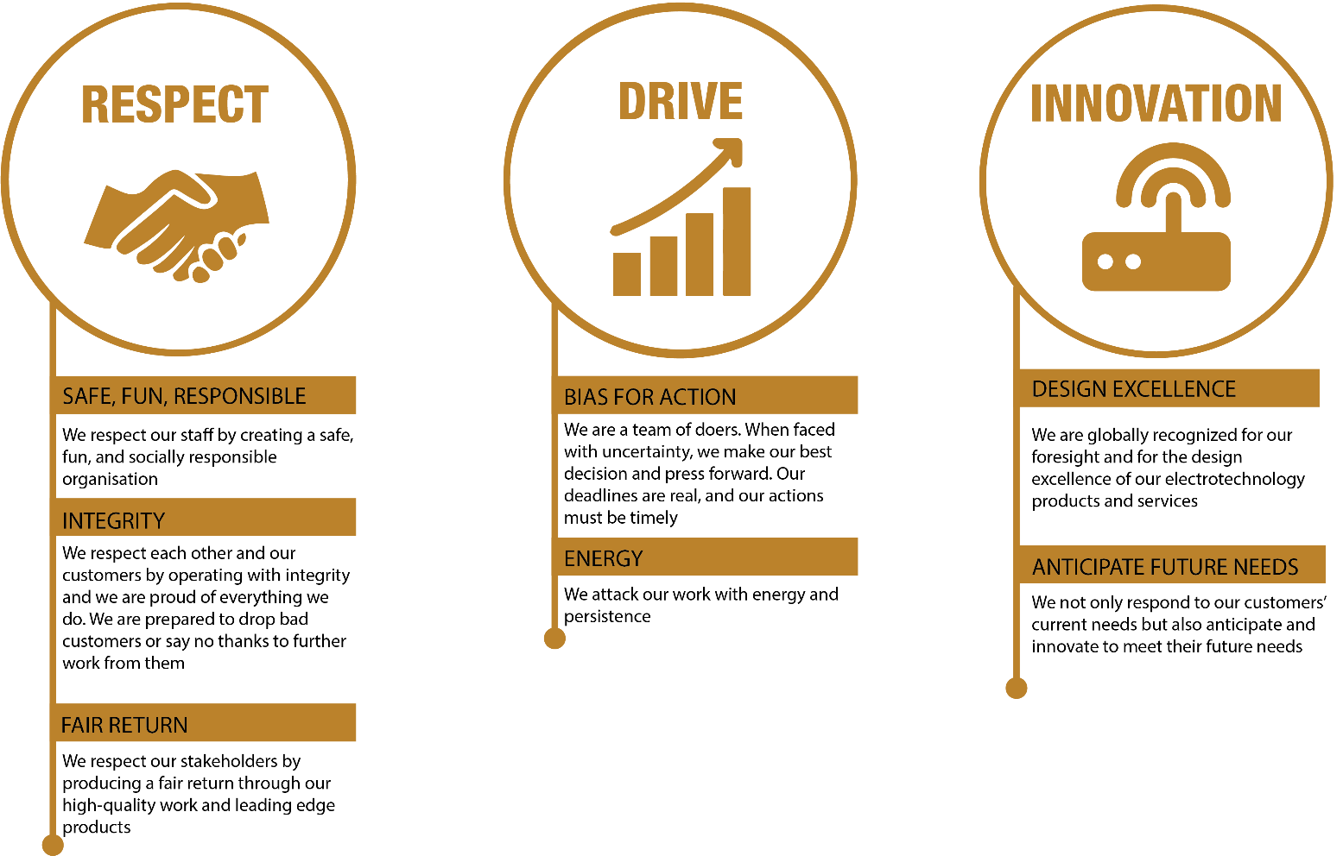

REVIEWED BY: |  |  | DATE:
Last updated by: | People and Culture |  | Date/Time: | May 2024

