|  |  |  |  |  |
| --- | --- | --- | --- | --- |
|  | | | | |
| **JOB TITLE:** | Marine Electrician | | | |
|  |  |  |  |  |
| Location: | Whangarei |  | Date: | February 2025 |
|  |  |  |  |  |
| Reports to: | Marine Manager | | | |
|  |  |  |  |  |
| Purpose: | To install, maintain, troubleshoot, and repair electrical systems on marine vessels such as ships, boats, and offshore platforms. | | | |
|  |  |  |  |  |
| **ROLE SUMMARY:** | | | | |
| Having started providing electrotechnology services in 1936, McKay is a historic New Zealand electrical company with a depth of experience in providing end to end electrical solutions for a wide range of industries and sectors. McKay is the parent brand and has acquired and started a range of companies under the McKay Group name in order to serve all electrical needs.  As a Marine Electrician at McKay Ltd., you will play a crucial role in ensuring the proper functioning and safety of electrical systems on marine vessels, contributing to the overall reliability and efficiency of maritime operations. | | | | |

|  |
| --- |
| RESPONSIBILITIES: |

1. **Installation and Wiring:**
   * Install and wire electrical systems on new marine vessels or during retrofitting.
   * Connect and secure wiring to various components, such as engines, generators, lighting systems, navigation equipment, and communication systems.
2. **Maintenance and Inspection:**
   * Conduct regular inspections of electrical systems to identify and address potential issues.
   * Perform preventive maintenance to ensure the reliability of electrical equipment.
   * Replace or repair faulty components, such as wiring, switches, and circuit breakers.
3. **Troubleshooting:**
   * Diagnose and troubleshoot electrical problems using testing equipment and technical manuals.
   * Identify and resolve issues in a timely manner to minimise downtime and ensure the safety of the vessel.
4. **Safety Compliance:**
   * Adhere to safety standards and regulations applicable to marine electrical systems.
   * Ensure that all electrical work meets industry codes and standards.
5. **Collaboration:**
   * Work closely with other marine professionals, including engineers, mechanics, and deckhands, to coordinate electrical work with overall vessel operations.
6. **Documentation:**
   * Maintain accurate records of electrical installations, repairs, and maintenance activities.
   * Document compliance with safety regulations and industry standards.
7. **Emergency Repairs:**
   * Respond to emergency repair calls to address critical electrical failures promptly.
8. **Upgrading Systems:**
   * Stay informed about new technologies and regulations in the marine electrical field.
   * Upgrade existing electrical systems to meet new requirements or improve efficiency.

|  |
| --- |
| QUALIFICATIONS & KNOWLEDGE: |

* Completion of a recognised apprenticeship program or relevant vocational training.
* Certification as a Marine Electrician or industrial experience.

|  |
| --- |
| ROLE PROFILE: |

As a Marine Electrician at McKay Ltd., you must hold the following capabilities;

* Knowledge of marine electrical systems, navigation equipment, and communication systems.
* Ability to read and interpret electrical schematics and technical manuals.
* Strong troubleshooting and problem-solving skills.
* Physical fitness and ability to work in challenging marine environments.

|  |
| --- |
| McKay GUIDING VALUES: |

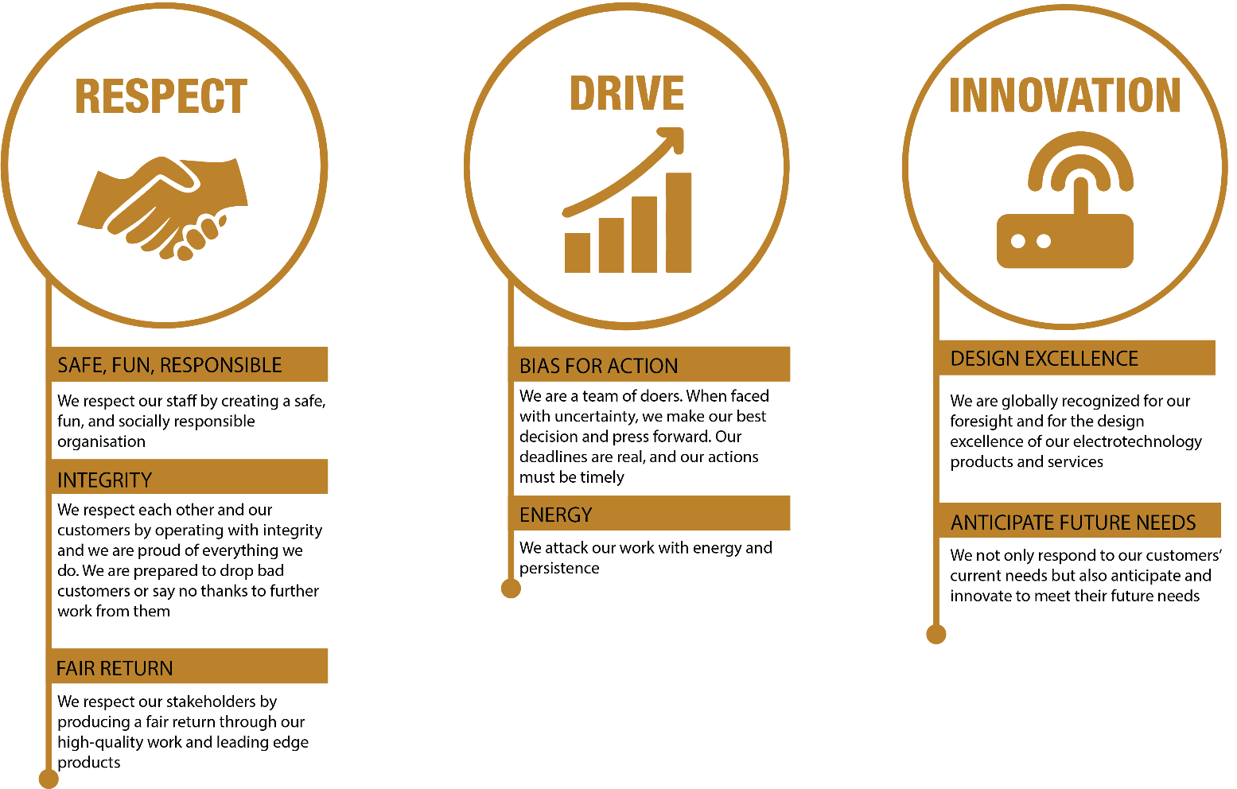

|  |  |  |  |  |
| --- | --- | --- | --- | --- |
| **REVIEWED BY:** | Ben Haselden |  | **DATE:** | 19/02/2025 |
|  |  |  |  |  |
| **Last updated by:** | People and Culture |  | **Date/Time:** | February 2025 |