Job description
Title | Branch Manager
Location
Start Date
Reports To
Reviewed By | Firstname Lastname | Date: | Month, 2025
Last Updated By | People & Culture | Date: | Month, 2025
Purpose:
To oversee the day-to-day operations of the branch, ensuring efficient and effective functioning of the team, and driving business growth in the assigned region.
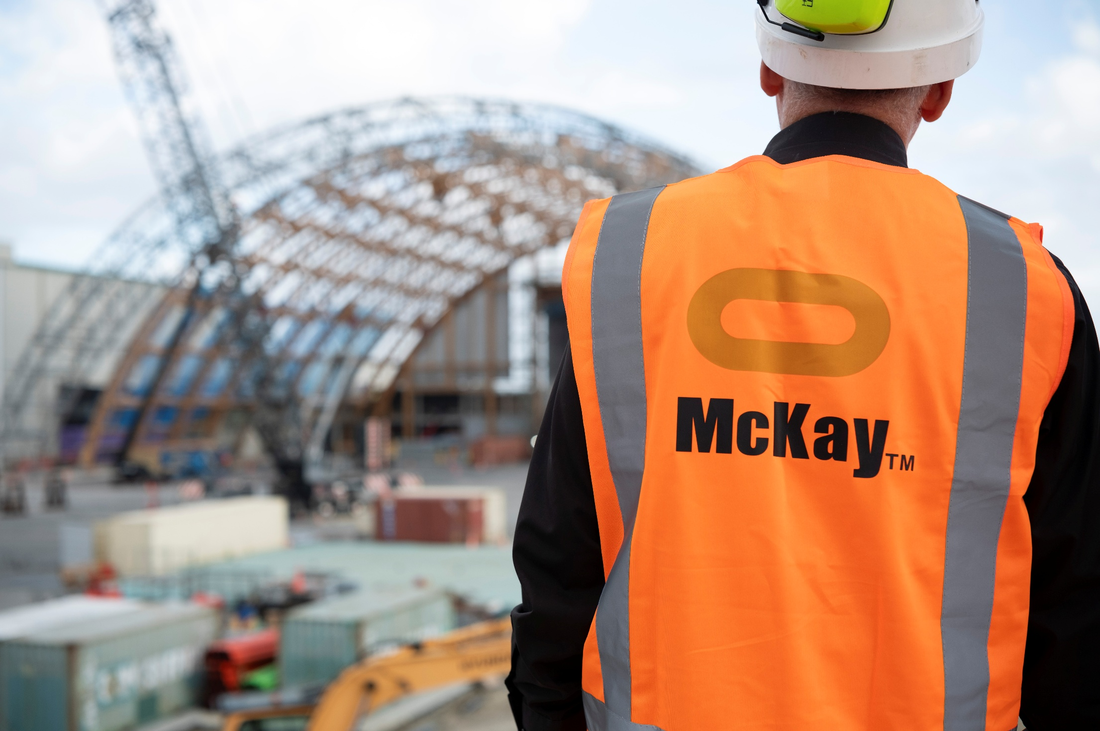



Role Summary
McKay is proud to stand as Aotearoa, New Zealand’s largest privately owned electrotechnology provider, offering innovative electrical engineering and construction services nationwide.
Having started providing electrotechnology services in 1936, McKay is a historic New Zealand electrical company with a depth of experience in providing end to end electrical solutions for a wide range of industries and sectors. McKay is the parent brand and has acquired and started a range of companies under the McKay Group name to serve all electrical needs.
As Branch Manager at McKay., you will be responsible for overseeing the day-to-day operations of the branch, ensuring efficient and effective functioning of the team, and driving business growth in the assigned region. This position requires strong leadership skills, in-depth knowledge of electrical products and services, and the ability to manage both people and resources.

Responsibilities

Leadership and Team Management
  - Provide strong leadership to the branch team, fostering a positive and collaborative work environment.
  - Supervise and motivate staff to achieve individual and collective goals.
  - Conduct regular team meetings to communicate goals, performance expectations, and updates.

Operational Excellence
  - Oversee the daily operations of the branch, ensuring adherence to company policies and procedures.
  - Oversea the management of resources to ensure efficiency and productivity meets or exceeds budgets
  - Implement and maintain safety protocols to ensure a secure working environment.

Customer Service
  - Develop and maintain strong customer relationships to drive customer satisfaction and loyalty.
  - Resolve customer complaints and issues promptly, ensuring a high level of customer service.
  - Proactively seek customer feedback and implement service improvements to ensure the branch consistently meets customer expectations.

Sales and Business Development
  - Develop and deliver a branch business development plan to achieve revenue and profitability targets through new work and repeat business.
  - Identify and pursue new business opportunities within the assigned region.
  - Manage the preparation, review and submission of tenders and quotations, ensuring accurate pricing.

Financial Management
  - Monitor and manage branch budget, expenses, and financial performance.
  - Implement cost-control measures to maximise profitability.
  - Prepare and analyse financial reports for senior management.

Training and Development
  - Identify training needs within the team and coordinate training programs accordingly.
  - Foster a culture of continuous learning and development.
  - Conduct performance reviews and provide constructive feedback to team members.

Qualifications & Knowledge
- Bachelor's degree in Business Administration, Electrical Engineering, or a related field.
- Proven experience in a managerial role, preferably in the electrical industry.

Role Profile
As a Branch Manager at McKay Ltd., you must hold the following capabilities;
- Strong knowledge of electrical products, systems, and industry trends.
- Excellent leadership, communication, and interpersonal skills.
- Ability to make sound decisions under pressure and adapt to changing circumstances.
- Proficient in Microsoft Office Suite and other relevant business software.

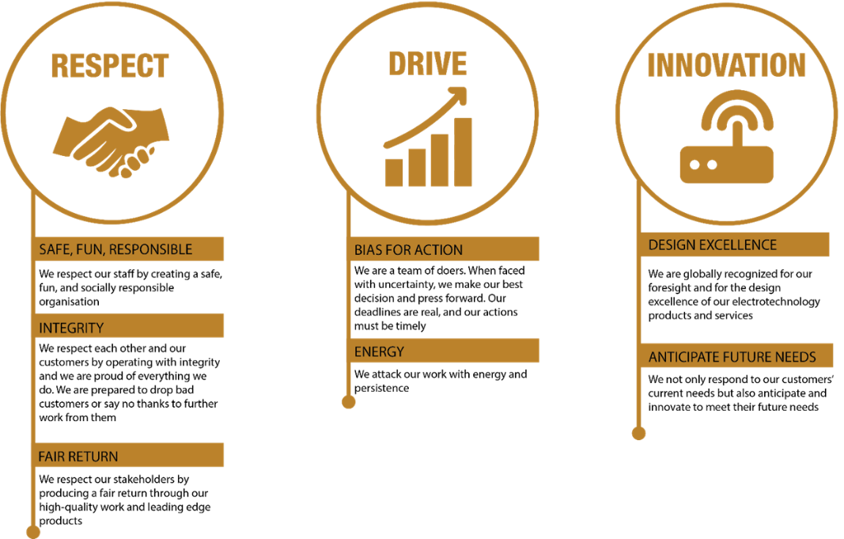
McKay Guiding Values

