Job description
Title | Electrical Fitter
Location
Start Date
Reports To
Reviewed By | Firstname Lastname | Date: | Month, 2025
Last Updated By | People & Culture | Date: | Month, 2025
Purpose:
To install, maintain and repair electrical systems and equipment.
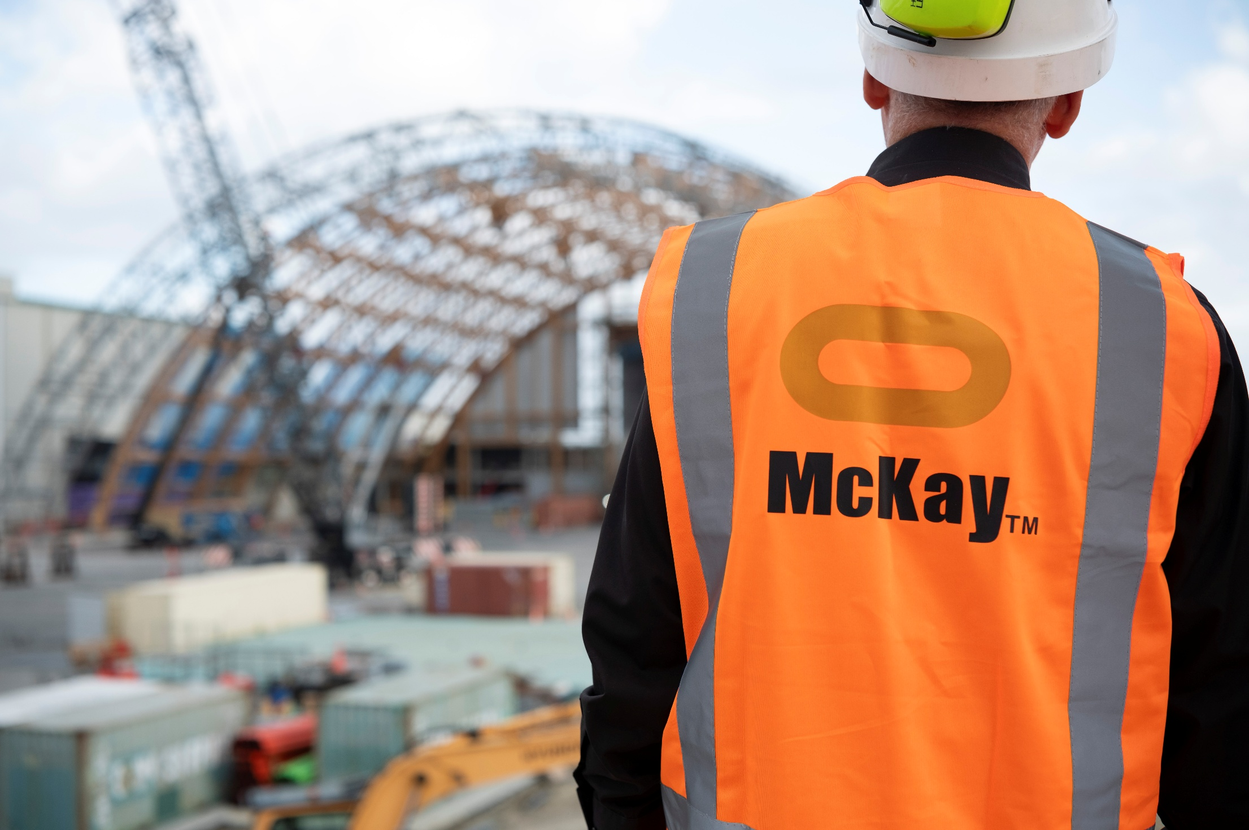



Role Summary
McKay is proud to stand as Aotearoa, New Zealand’s largest privately owned electrotechnology provider, offering innovative electrical engineering and construction services nationwide.
Having started providing electrotechnology services in 1936, McKay is a historic New Zealand electrical company with a depth of experience in providing end to end electrical solutions for a wide range of industries and sectors. McKay is the parent brand and has acquired and started a range of companies under the McKay Group name to serve all electrical needs.
As an Electrical Fitter at McKay Electrical Ltd., you are responsible for installing, maintaining, and repairing electrical systems and equipment. This role requires a strong understanding of electrical components, wiring, and systems, as well as the ability to work safely and efficiently.

Responsibilities
Installation:
- Install and connect electrical systems, equipment, and wiring in compliance with relevant electrical codes and regulations.
Maintenance:
- Perform routine maintenance on electrical systems and equipment to ensure optimal performance and safety.
Repairs:
- Diagnose and repair electrical faults, malfunctions, or breakdowns in various systems, including lighting, power distribution, and machinery.
Testing:
- Conduct electrical testing and inspections to identify and rectify issues, ensuring that systems meet safety and performance standards.
Blueprints and Diagrams:
- Interpret electrical blueprints, diagrams, and technical specifications to accurately install and troubleshoot electrical components.
Safety:
- Adhere to safety protocols and guidelines to ensure a safe working environment, including lockout/tagout procedures and the use of personal protective equipment.
Tools and Equipment:
- Properly use and maintain electrical tools and equipment, such as multimeters, conduit benders, and power drills.
Documentation:
- Maintain accurate records of work performed, including repairs, maintenance, and inspection reports.
Collaboration:
- Work collaboratively with other team members, including electricians, engineers, and supervisors, to complete projects and tasks efficiently.
Compliance:
- Stay up-to-date with local and national electrical codes and regulations, and ensure all work meets these standards.

Qualifications & Knowledge
- Completion of a recognised Electrical Fitter apprenticeship program.
- Prior experience as an Electrical Fitter or in a related electrical field.
- Electrician's license / NZ relevant certification.

Role Profile
As an Electrical Fitter at McKay Electrical Ltd., you must hold the following capabilities;
- Strong knowledge of electrical systems, components, and wiring.
- Proficiency in using electrical testing equipment.
- Ability to read and interpret electrical blueprints and diagrams.
- Excellent problem-solving skills.
- Strong attention to detail.
- Good communication and teamwork skills.
- Physical fitness and the ability to work in various conditions, including tight spaces and at heights.
- Understanding of safety protocols and the ability to work safely.


McKay Guiding Values

