Job description
Title | Maintenance Electrician
Location | Whangarei, Northland
Start Date | December, 2025
Reports To | Ross Butler
 | Northland Maintenance
Reviewed By | Hannah Boyd | Date: | December, 2025
Last Updated By | People & Culture | Date: | December, 2025
Purpose:
To ensure the proper functioning and safety of electrical systems within a facility or organisation.
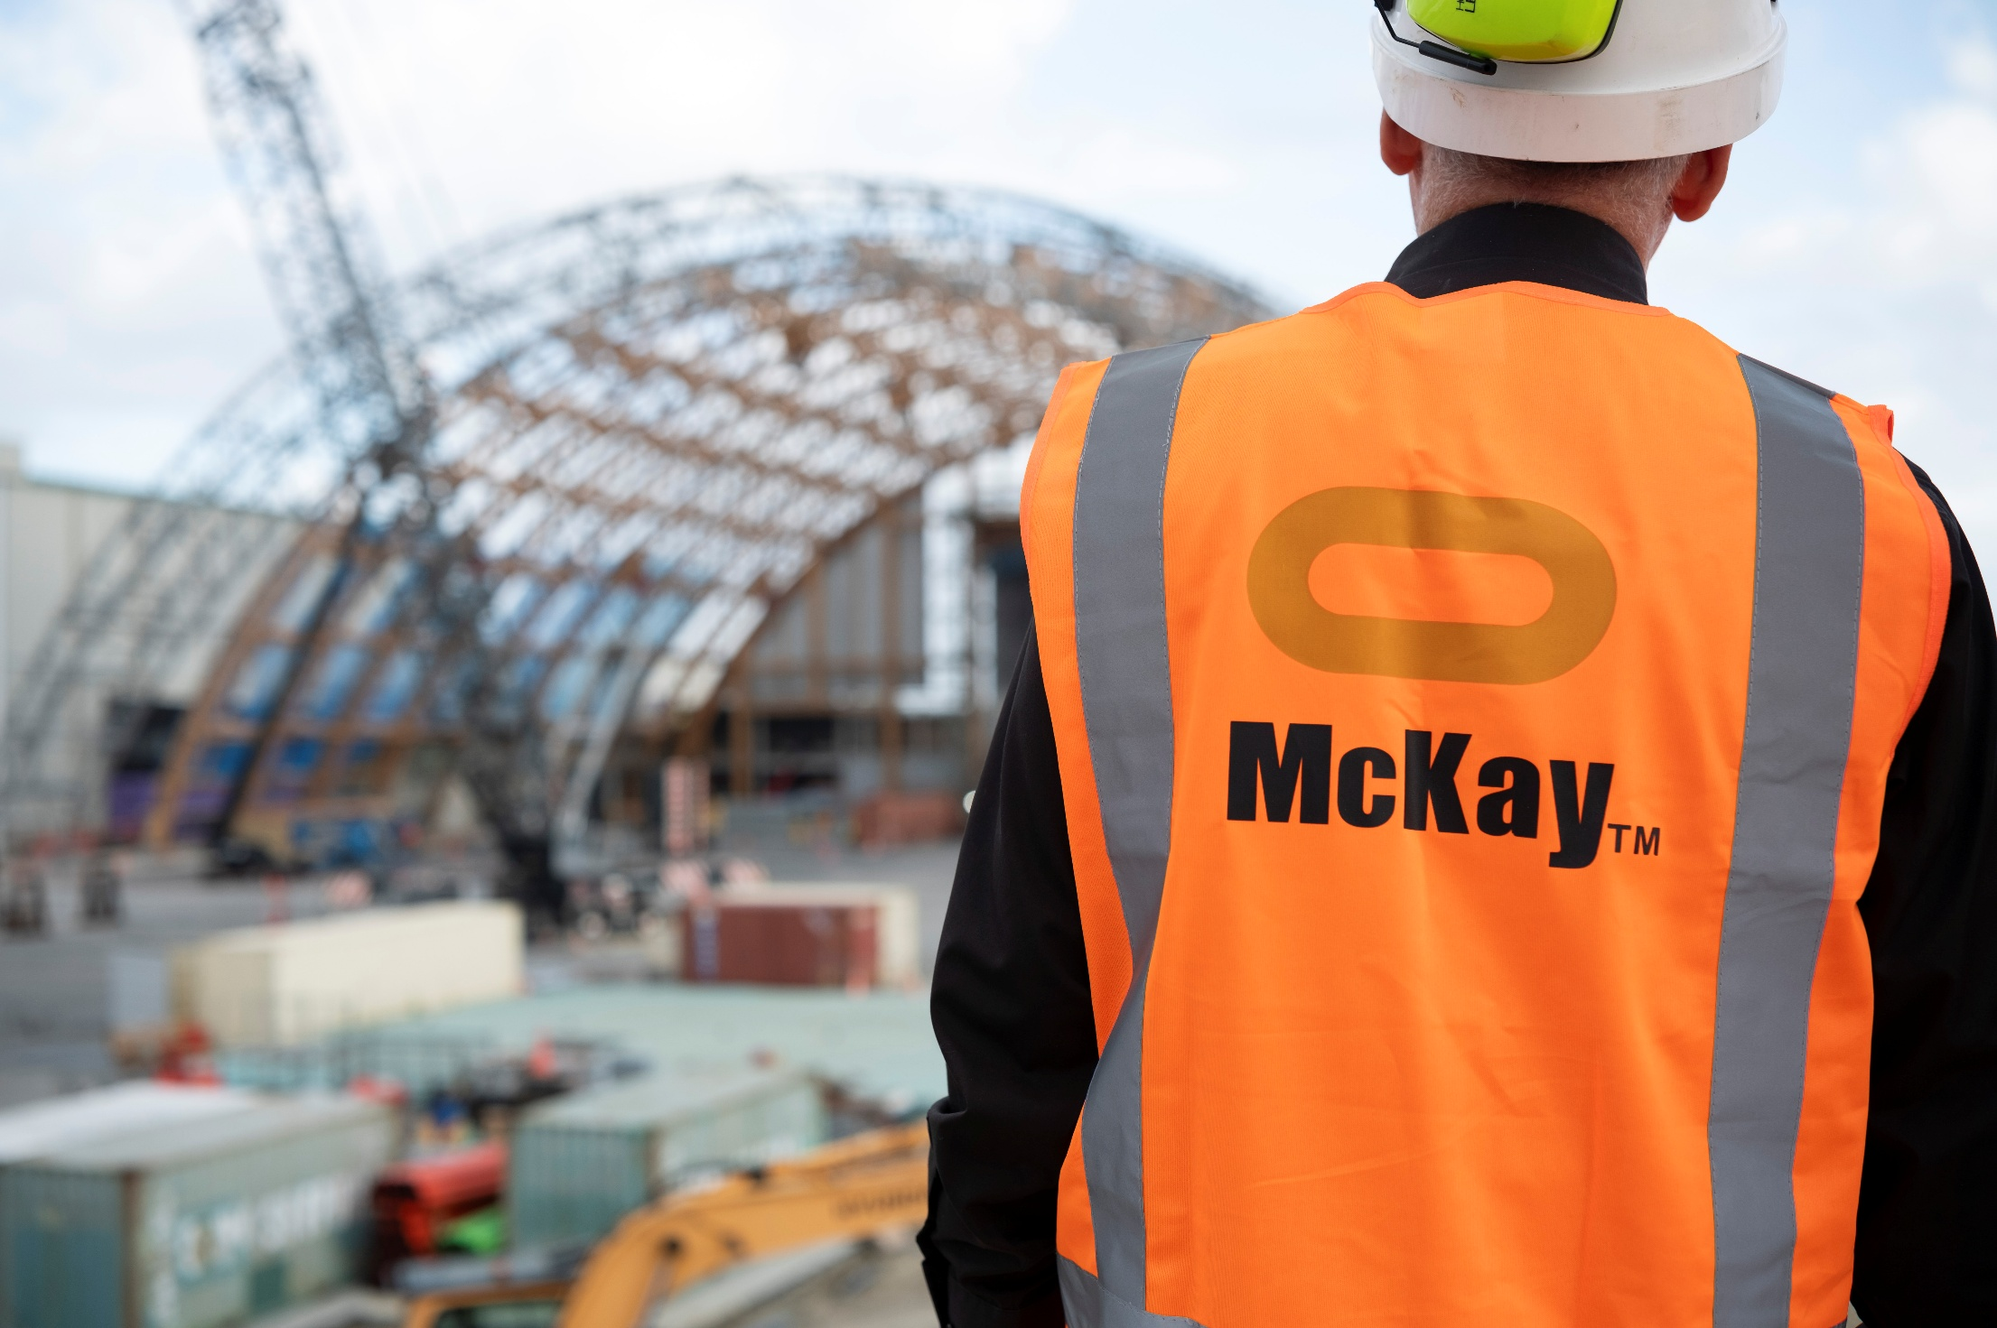



Role Summary
McKay is proud to stand as Aotearoa, New Zealand’s largest privately owned electrotechnology provider, offering innovative electrical engineering and construction services nationwide.
Having started providing electrotechnology services in 1936, McKay is a historic New Zealand electrical company with a depth of experience in providing end to end electrical solutions for a wide range of industries and sectors. McKay is the parent brand and has acquired and started a range of companies under the McKay Group name to serve all electrical needs.
As Maintenance Electrician at McKay Electrical Ltd., you are responsible for ensuring the proper functioning and safety of electrical systems within a facility or organisation. This role involves performing preventive maintenance, troubleshooting electrical issues, and repairing or replacing faulty components. Maintenance Electricians work in a variety of settings, including industrial plants, commercial buildings, and residential complexes.

Responsibilities

Routine Inspections
  - Conduct regular inspections of electrical systems to identify and address potential issues.
  - Check wiring, lighting, motors, and other electrical components for signs of wear, damage, or malfunctioning.

Preventive Maintenance
  - Develop and implement a preventive maintenance schedule for electrical systems and equipment.
  - Perform routine maintenance tasks to ensure the longevity and optimal performance of electrical systems.

Troubleshooting
  - Diagnose electrical problems using testing devices and tools.
  - Identify the root causes of malfunctions and implement effective solutions.

Repairs and Replacements
- Repair or replace faulty electrical components such as wiring, switches, relays, and circuit breakers.
- Install new electrical systems or components as needed.

Emergency Response
- Respond promptly to emergency calls and resolve electrical issues to minimise downtime.
- Collaborate with other maintenance personnel to address urgent electrical problems.

Documentation
- Maintain accurate records of inspections, repairs, and maintenance activities.
- Document changes made to electrical systems and update electrical drawings as necessary.

Compliance
- Ensure compliance with local electrical codes, regulations, and safety standards.
- Stay informed about updates to electrical codes and industry best practices.

Collaboration
- Coordinate with other maintenance staff, engineers, and supervisors to address cross-discipline issues.
- Communicate effectively with team members and provide assistance as needed.

Safety
- Follow and promote safety protocols to prevent accidents and injuries.
- Conduct safety inspections and report any hazards or violations.

Qualifications & Knowledge
- Completion of an electrical apprenticeship program or relevant vocational training.
- Appropriate national electrician’s licence.

Role Profile
As a Maintenance Electrician at McKay Electrical Ltd., you must hold the following capabilities;
- Strong knowledge of electrical codes and regulations.
- Proficiency in reading blueprints and technical diagrams.
- Excellent problem-solving and troubleshooting skills.
- Physical stamina and the ability to work in various environments, including confined spaces.
- Strong attention to detail and safety-conscious.
- Good communication and customer service skills.
- Basic computer skills for recordkeeping and communication.

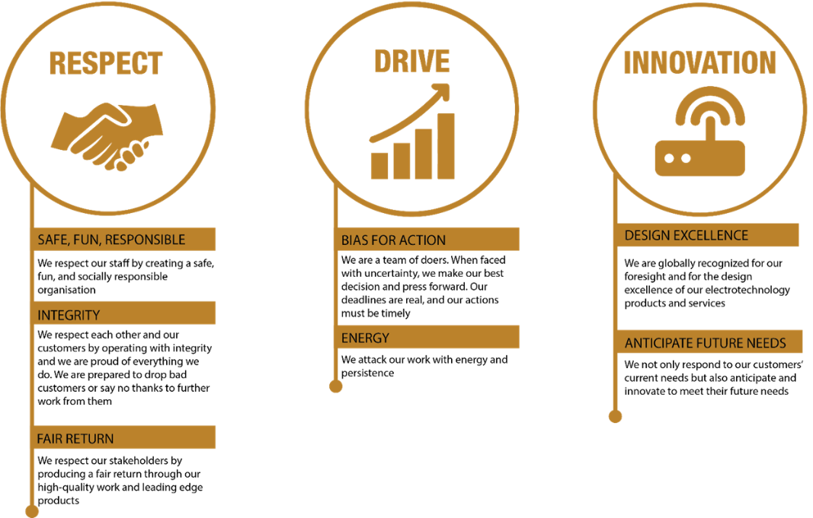
McKay Guiding Values

