Job description
Title | Leading Hand
Location | City, Region
Start Date | Month, 2025
Reports To | Name or To Be Confirmed
 | [Department or Division]
Reviewed By | Firstname Lastname | Date: | Month, 2025
Last Updated By | People & Culture | Date: | Month, 2025
Purpose:
To oversee and coordinate the activities of a team of electricians or electrical technicians.
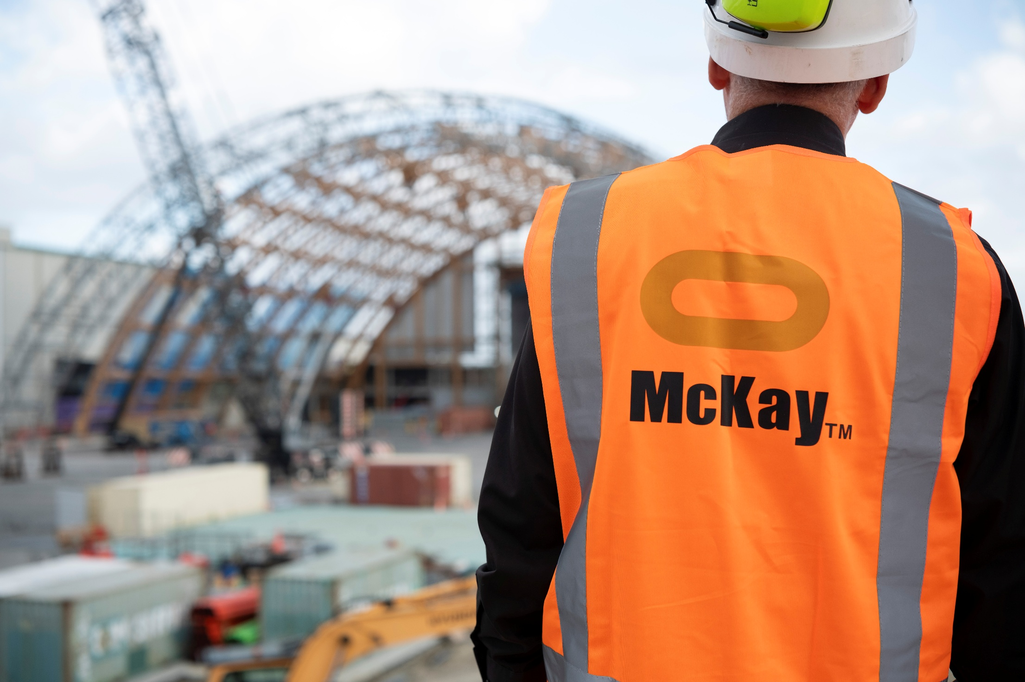



Role Summary
McKay is proud to stand as Aotearoa, New Zealand’s largest privately owned electrotechnology provider, offering innovative electrical engineering and construction services nationwide.
Having started providing electrotechnology services in 1936, McKay is a historic New Zealand electrical company with a depth of experience in providing end to end electrical solutions for a wide range of industries and sectors. McKay is the parent brand and has acquired and started a range of companies under the McKay Group name to serve all electrical needs.
As the Leading Hand at McKay Ltd., you will play a crucial role in overseeing and coordinating the activities of a team of electricians or electrical technicians. This position requires a strong technical background in electrical systems, excellent leadership skills, and the ability to manage and prioritise tasks efficiently.

Responsibilities

Team Leadership
  - Lead, motivate, and supervise a team of electricians/electrical technicians.
  - Allocate tasks and responsibilities to team members based on their skills and expertise.
  - Conduct regular team meetings to communicate project objectives, expectations, and updates.
  - As a people leader, it's important that when you're away from work for any reason, you delegate your responsibilities and clearly communicate to your team who will be covering in your absence.

Technical Expertise
  - Demonstrate a high level of technical proficiency in electrical systems and equipment.
  - Provide hands-on support and guidance to team members during complex installations, repairs, and maintenance activities.
  - Stay updated on industry trends, technological advancements, and safety regulations.

Project Management
  - Oversee the planning, execution, and completion of electrical projects.
  - Collaborate with project managers to ensure timelines and budgets are met.
  - Monitor project progress and address any issues that may arise during the course of the project.

Quality Assurance
- Ensure that all work meets the quality standards and adheres to relevant codes and regulations.
- Conduct inspections and quality checks on completed work.
- Implement corrective actions as needed to address quality issues.

Safety Compliance
  - Enforfe and promote a strong safety culture within the team.
  - Conduct regular safety briefings and training sessions.
  - Investigate and report any accidents or safety incidents.

Communication
  - Effectively communicate with team members, management, and clients.
  - Provide regular updates on project status, challenges, and achievements.
  - Foster open communication within the team to encourage feedback and collaboration.

Qualifications & Knowledge
- Minimum of 5 years’ experience in the electrical industry.
- Relevant electrical trade qualification or certification.

Role Profile
As a Leading Hand at McKay LTD., you must hold the following capabilities.
- Strong leadership and interpersonal skills.
- Excellent problem-solving skills.
- Knowledge of electrical codes, regulations, and safety standards.
- Project management experience is a plus.

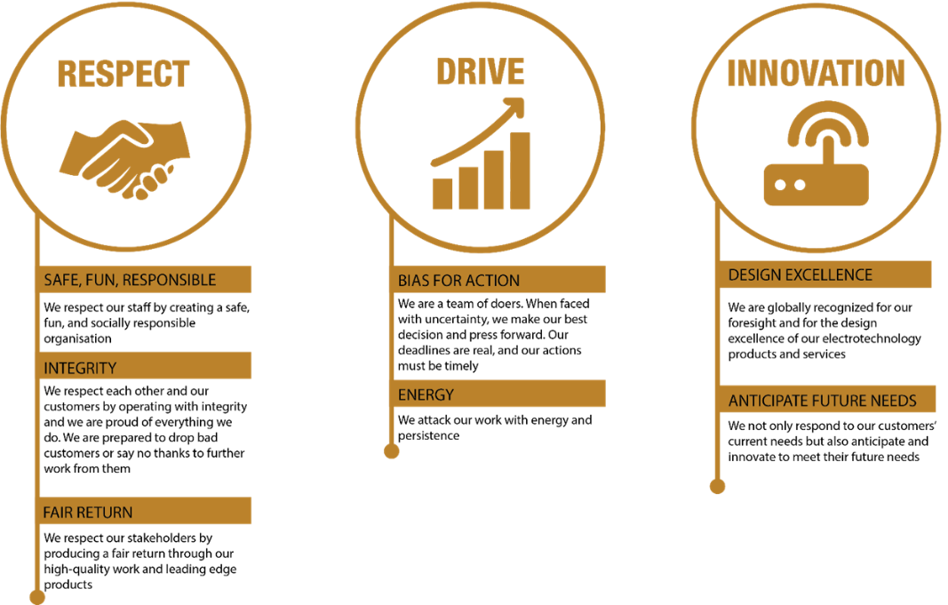
McKay Guiding Values

